Odsek Visoka ICT škola,  
Akademija tehničko-umetničkih strukovnih studija,  
Beograd

officeware

[http://officeware.epizy.com/](https://mihailoilic.github.io/TravelScene/)

Smer: Internet tehnologije

Modul: Web programiranje

Predmet: Web programiranje PHP 1

Mihailo Ilić 41/19

Sadržaj

1. Uvod 3

1.1 Korišćeni programski jezici/tehnologije 3

1.2 Opis funkcionalnosti 3

1.2 Template 4

2. Organizacija 4

2.1 Organizaciona šema i šema baze podataka 4

2.2 Mapa sajta 4

2.3 Slike stranica i opisi funkcionalnosti 7

2.3.1 index.php 7

2.3.2 shop.php 8

2.3.3 product.php 9

2.3.4 login.php 10

2.3.5 register.php 11

2.3.6 cart.php 12

2.3.7 account.php 13

2.3.8 poll.php 14

2.3.9 contact.php 15

2.3.10 author.php 16

2.3.11 admin-products.php 17

2.3.12 admin-product-edit.php 18

2.3.13 admin-users.php 19

2.3.14 admin-messages.php 20

2.3.15 admin-poll.php 21

3. Kodovi 22

3.1 PHP 22

3.1.1 index.php 22

3.1.2 shop.php 23

3.1.3 product.php 25

3.1.4 login.php 27

3.1.5 register.php 28

3.1.6 account.php 29

3.1.7 cart.php 31

3.1.8 contact.php 31

3.1.9 author.php 33

3.1.10 poll.php 34

3.1.11 admin-products.php 35

3.1.12 admin-product-edit.php 37

3.1.13 admin-users.php 40

3.1.14 admin-messages.php 41

3.1.15 admin-poll.php 43

3.1.16 config/connection.php 44

3.1.17 models/admin-change-pw.php 44

3.1.18 models/cart-operations.php 45

3.1.18 models/delete-data.php 48

3.1.19 models/delete-message.php 50

3.1.20 models/functions.php 51

3.1.21 models/get-data.php 54

3.1.22 models/insert-data.php 56

3.1.23 models/login.php 60

3.1.24 models/logout.php 61

3.1.25 models/poll-vote.php 62

3.1.26 models/registration.php 63

3.1.27 models/send-message.php 65

3.1.28 models/session.php 66

3.1.29 models/user-change-pw.php 66

3.1.30 views/footer.php 67

3.1.31 views/head.php 68

3.1.32 views/nav.php 69

3.2 CSS (SCSS) 71

3.2.1 assets/css/style.scss 71

3.3 JavaScript 78

3.3.1 assets/js/main.js 78

# 1. Uvod

## 1.1 Korišćeni programski jezici/tehnologije

Za potrebe sajta korišćene su sledeće tehnologije:

* HTML
* CSS + SASS
* Bootstrap (samo CSS) + Font Awesome
* JavaScript + jQuery
* PHP
* Xampp + MySQL
* jQuery plugin – slick
* Visual Studio Code
* Photoshop

## 1.2 Opis funkcionalnosti

Funkcionalnosti sajta se mogu svrstati u sledeće kategorije:

* **Dinamičko učitavanje navigacije iz baze**, u ovo ulaze i linkovi posvećeni administratorskim nalozima
* **Slajder** sa slikama koje se učitavaju dinamički iz baze
* **Dinamička prodavnica sa dinamičkom stranicom o izabranom proizvodu**, a sadržaj se preuzima iz baze
* **Filtriranje, pretraga, sortiranje i straničenje proizvoda na stranici za prodavnicu**, sve se obavlja jednim upitom na osnovu izabranih kriterijuma
* **Korpa** koja je povezana sa korisničkim nalogom, sa ukupnom sumom i opcijama za brisanje i izmenu količine
* **Registracija i logovanje od strane korisnika**, sve se proverava regularnim izrazima, a sve stranice za korisnike/administratore su zaštićene od neautorizovanih posetilaca
* **Stranica o nalogu korisnika** gde korisnik može videti svoje informacije i promeniti lozinku
* **Anketa** gde korsnici glasaju, a administratori imaju uvid o tome koliko je glasova dobila koja opcija
* **Kontakt forma** – ime i imejl adresa se automatski popunjavaju ako je korisnik ulogovan, a administratori imaju uvid u poruke poslate kroz ovu formu
* **Administratorske funkcionalnosti**, obuhvataju stranice gde administratori mogu dodavati i brisati kategorije, brendove, proizvode itd., a takođe imaju uvid i opcije vezane za korisničke naloge, poruke i anketu
* **Forma za dodavanje i izmenjivanje proizvoda**, uključujući i uploadovanje slike, a unos se proverava i na klijentu i na serveru regularnim izrazima
* **Učitavanje iz zasebnog php fajla** navigacije, futera, i sadržaja head taga, kao i mnogih funkcionalnosti PHP koda koje se ponavljaju

## 1.2 Template

Za izradu sajta nije korišćeno gotovo rešenje. Sve funkcionalnosti i kod su napisani ispočetka.

# 2. Organizacija

## 2.1 Organizaciona šema i šema baze podataka

Skoro svim stranicama je dozvoljen pristup sa bilo kog mesta u zavisnosti od autorizacije.

Ovo su stranice sa kojima to nije slučaj:

* product.php – Dostupna preko stranice shop.php, kada se klikne na određni proizvod
* admin-product-edit.php – Dostupna preko stranice admin-products.php (admin panel) ili product.php (proizvod iz prodavnice), u zavisnosti da li administrator dodaje novi proizvod ili izmenjuje postojeći
* poll.php – Dostupna preko stranice index.php

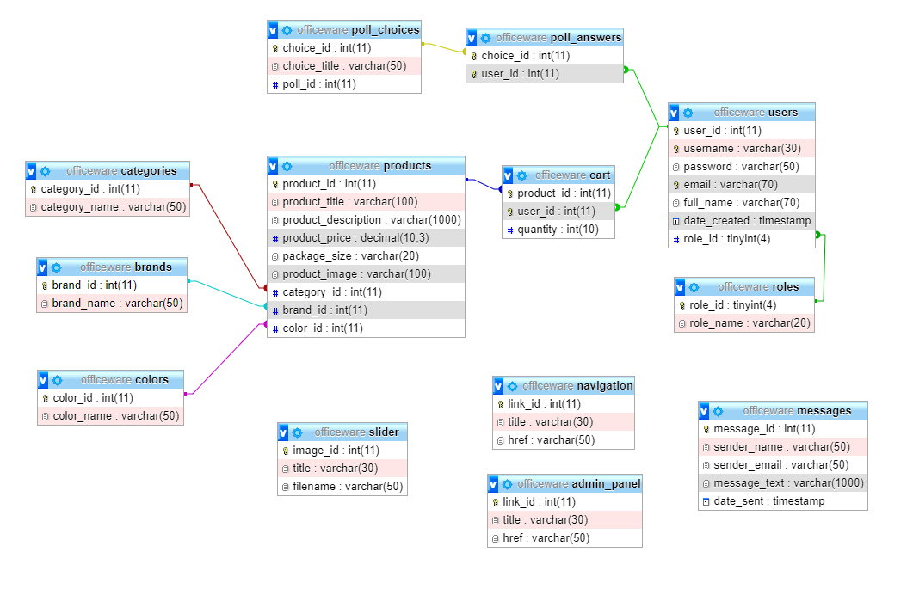

## 2.2 Mapa sajta

<?xml version="1.0" encoding="UTF-8"?>

<urlset xmlns="http://www.sitemaps.org/schemas/sitemap/0.9">

<url>

  <loc>http://officeware.epizy.com/</loc>

  <lastmod>2020-03-08</lastmod>

  <changefreq>weekly</changefreq>

  <priority>0.9</priority>

</url>

<url>

  <loc>http://officeware.epizy.com/shop.php</loc>

  <lastmod>2020-03-08</lastmod>

  <changefreq>daily</changefreq>

  <priority>1</priority>

</url>

<url>

  <loc>http://officeware.epizy.com/product.php</loc>

  <lastmod>2020-03-08</lastmod>

  <changefreq>daily</changefreq>

  <priority>1</priority>

</url>

<url>

  <loc>http://officeware.epizy.com/account.php</loc>

  <lastmod>2020-03-08</lastmod>

  <changefreq>monthly</changefreq>

  <priority>0.6</priority>

</url>

<url>

  <loc>http://officeware.epizy.com/admin-messages.php</loc>

  <lastmod>2020-03-08</lastmod>

  <changefreq>monthly</changefreq>

  <priority>0.6</priority>

</url>

<url>

  <loc>http://officeware.epizy.com/admin-products.php</loc>

  <lastmod>2020-03-08</lastmod>

  <changefreq>monthly</changefreq>

  <priority>0.6</priority>

</url>

<url>

  <loc>http://officeware.epizy.com/admin-product-edit.php</loc>

  <lastmod>2020-03-08</lastmod>

  <changefreq>daily</changefreq>

  <priority>0.6</priority>

</url>

<url>

  <loc>http://officeware.epizy.com/admin-users.php</loc>

  <lastmod>2020-03-08</lastmod>

  <changefreq>monthly</changefreq>

  <priority>0.6</priority>

</url>

<url>

  <loc>http://officeware.epizy.com/admin-poll.php</loc>

  <lastmod>2020-03-08</lastmod>

  <changefreq>monthly</changefreq>

  <priority>0.6</priority>

</url>

<url>

  <loc>http://officeware.epizy.com/cart.php</loc>

  <lastmod>2020-03-08</lastmod>

  <changefreq>daily</changefreq>

  <priority>0.9</priority>

</url>

<url>

  <loc>http://officeware.epizy.com/login.php</loc>

  <lastmod>2020-03-08</lastmod>

  <changefreq>yearly</changefreq>

  <priority>0.9</priority>

</url>

<url>

  <loc>http://officeware.epizy.com/register.php</loc>

  <lastmod>2020-03-08</lastmod>

  <changefreq>yearly</changefreq>

  <priority>0.9</priority>

</url>

<url>

  <loc>http://officeware.epizy.com/poll.php</loc>

  <lastmod>2020-03-08</lastmod>

  <changefreq>weekly</changefreq>

  <priority>0.9</priority>

</url>

<url>

  <loc>http://officeware.epizy.com/contact.php</loc>

  <lastmod>2020-03-08</lastmod>

  <changefreq>yearly</changefreq>

  <priority>0.6</priority>

</url>

<url>

  <loc>http://officeware.epizy.com/author.php</loc>

  <lastmod>2020-03-08</lastmod>

  <changefreq>yearly</changefreq>

  <priority>0.4</priority>

</url>

</urlset>

## 2.3 Slike stranica i opisi funkcionalnosti

### 2.3.1 index.php

 

Na ovoj stranici se nalazi slajder (slick - jQuery plugin), za koji su slajdovi dinamički učitani iz baze. Takođe, ovde se nalaze linkovi ka prodavnici i anketi. Ako korisnik nije prijavljen dugme za anketu je lažno i na klik će se samo pojaviti linkovi za login ili registraciju.

Navigacija i admin panel (ako je nalog administratorski) su učitani iz baze, a tu su i linkovi ka korpi i informacijama o nalogu, kao i link za odjavu (naravno, samo ako je korisnik ulogovan).

### 2.3.2 shop.php

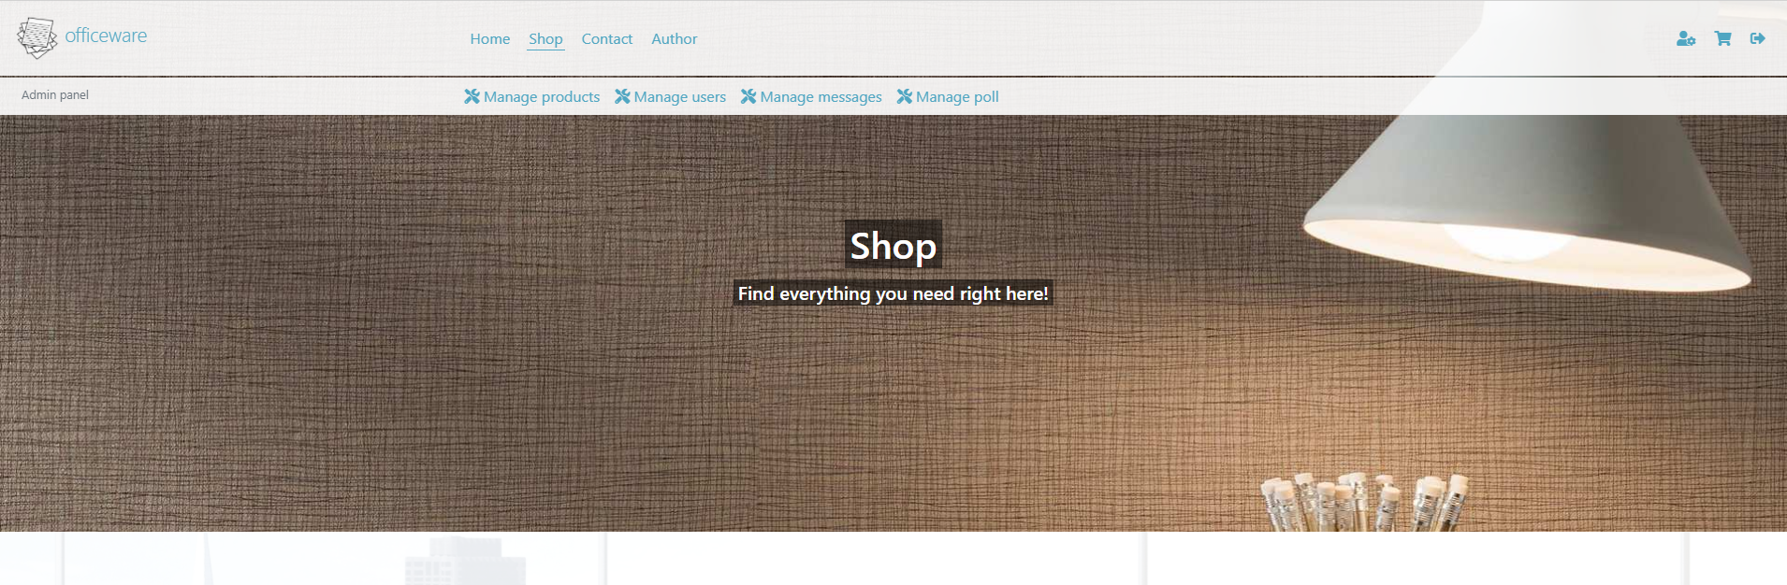 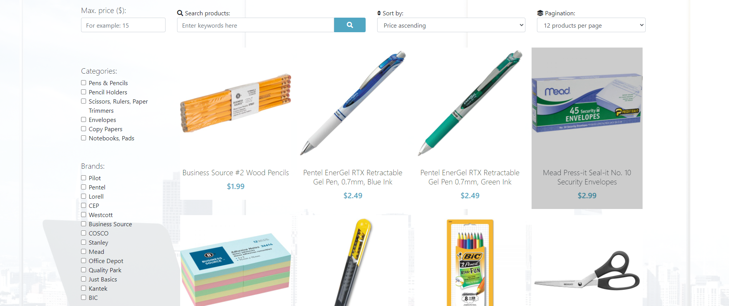

Na dnu:



Na ovoj stranici se mogu videti svi proizvodi. Sve kategorije, brendovi, boje i sami proizvodi se čitaju iz baze. Ovo se realizuje preko AJAX-a.

Moguće je filtriranje po kategorijama, brendovima, bojama i ceni. Tu je i mogućnost sortiranja, pretrage i straničenja (12, 24, i bez straničenja).

Za sve ove kriterijume na serveru se priprema poseban upit bazi nadovezivanjem stringova, i tako se jednim upitom dobijaju svi željeni podaci, a lista se osvežava prilikom svake interakcije korisnika sa ovim poljima.

Serveru se inicijalno traži prva stranica, a server nazad vraća koliko zapravo stranica postoji i tako se dinamički kreiraju linkovi ka ostalim stranicama (ukoliko ih ima).

Klikom na proizvod odlazi se na stranicu za više informacija o tom proizvodu.

### 2.3.3 product.php

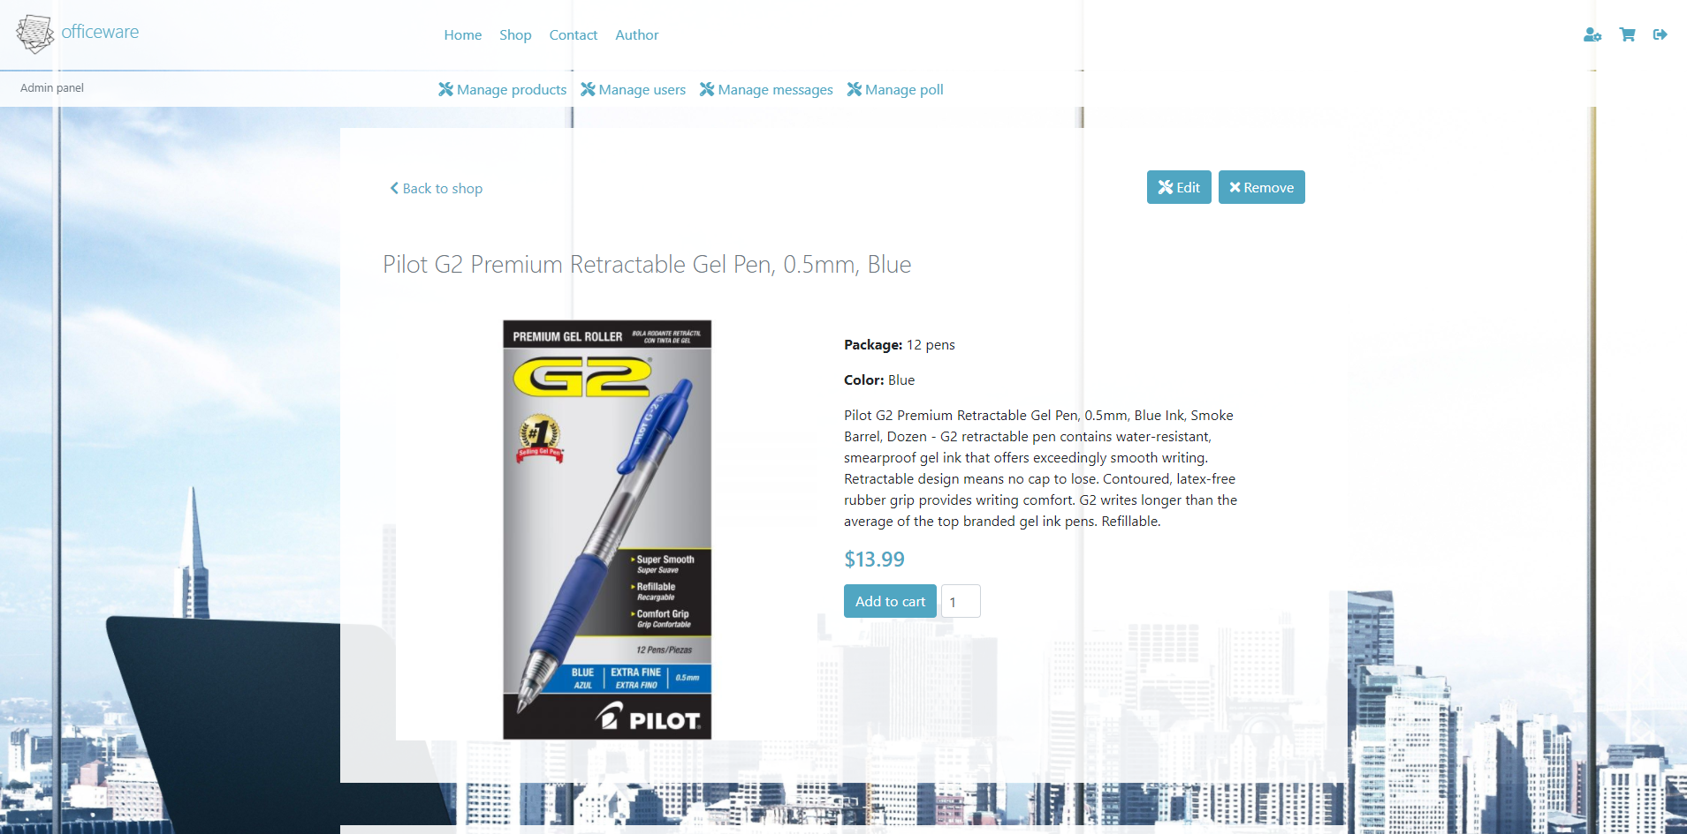

Ova stranica se dinamički popunjava u zavisnosti od toga koji je proizvod izabran. ID se čita preko GET superglobalne promenljive, a to se dalje obrađuje preko JavaScripta i AJAX-a.

Postoji i opcija za dodavanje u korpu zajedno sa količinom, a ako korisnik nije ulogovan onda je to dugme lažno i samo izdaje obaveštenje da se posetilac mora ulogovati ili registrovati.

### 2.3.4 login.php

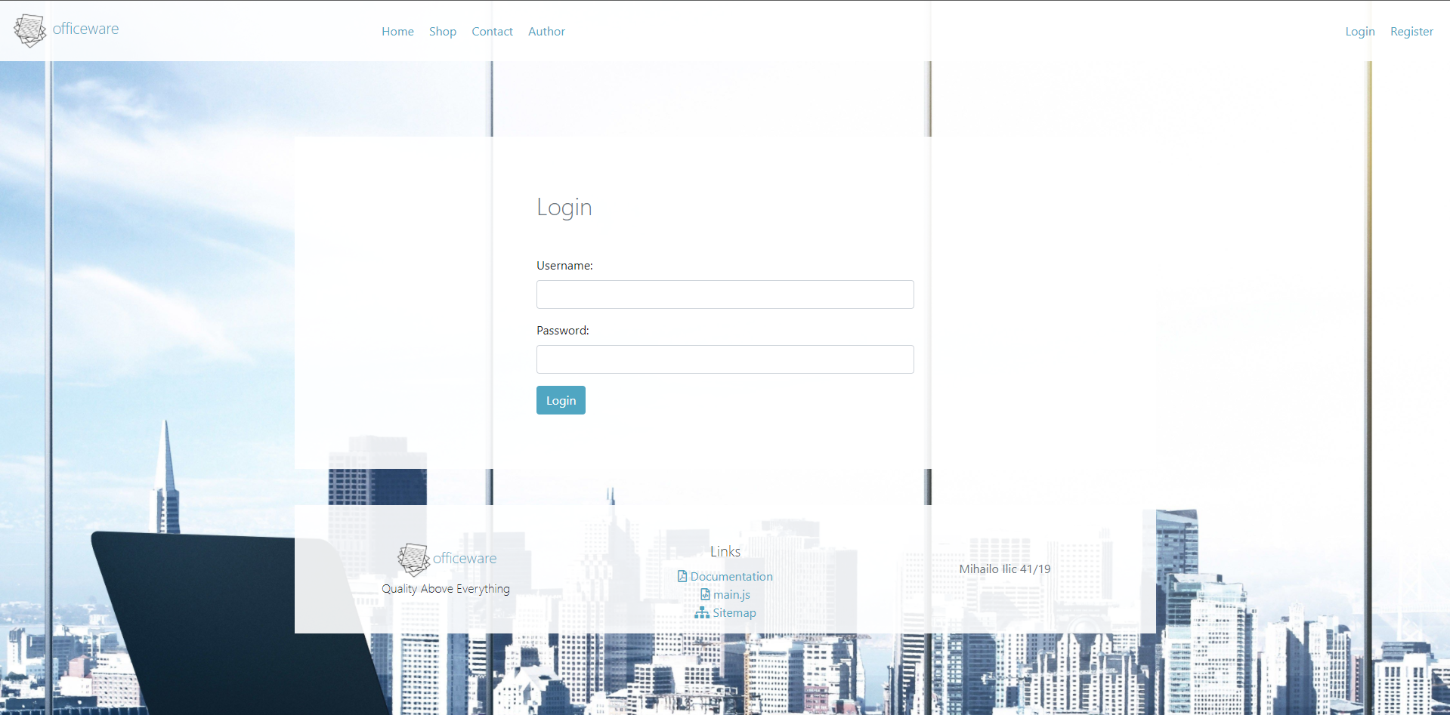

Na ovoj stranici posetioci se mogu ulogovati, a kredencijali se proveravaju na serveru. Polja se takođe proveravaju JavaScriptom kako se ne bi slali bespotrebni zahtevi ka serveru.

### 2.3.5 register.php

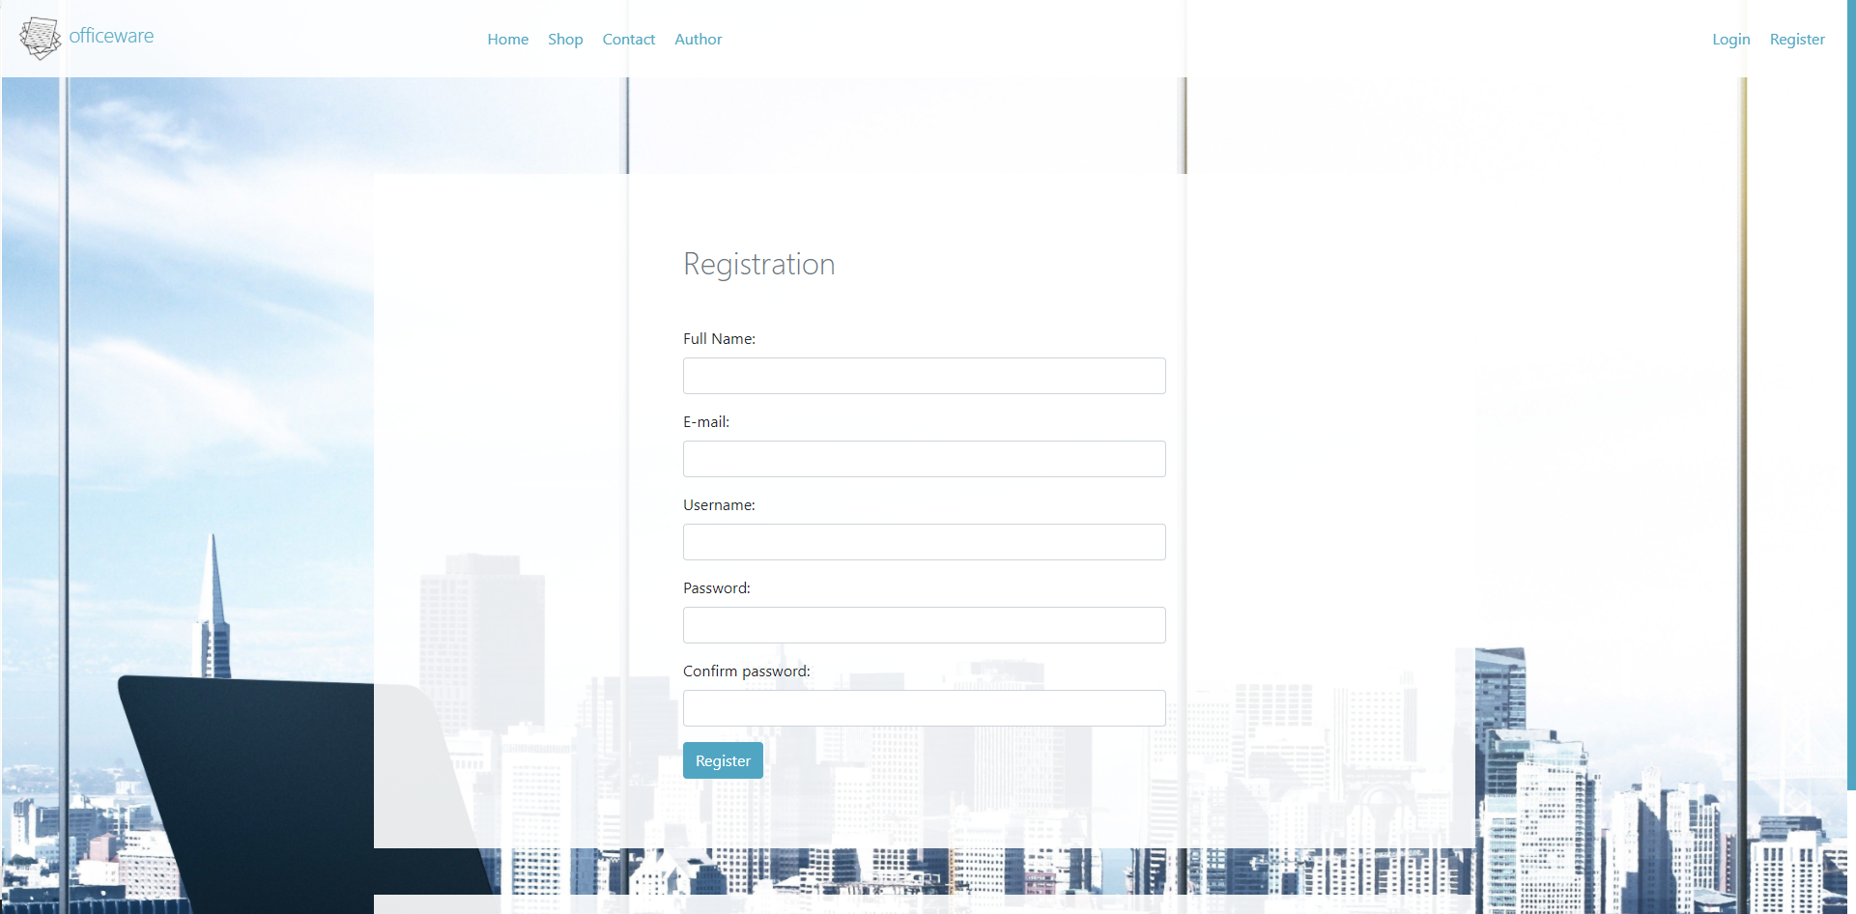

Ovde se vrši registracija novih korisnika, sva polja se proveravaju regularnim izrazima na oba kraja. Takođe ne mogu se registrovati dva naloga sa istim korisničkim imenom ili imejl adresom, a krajnji korisnik će biti obavešten o ishodu registracije.

Ako je sve ispravno upisuju se podaci u bazu korišćenjem addslashes i bindParam, radi veće sigurnosti. A lozinke se upisuju samo kao md5 kriptografija.

### 2.3.6 cart.php

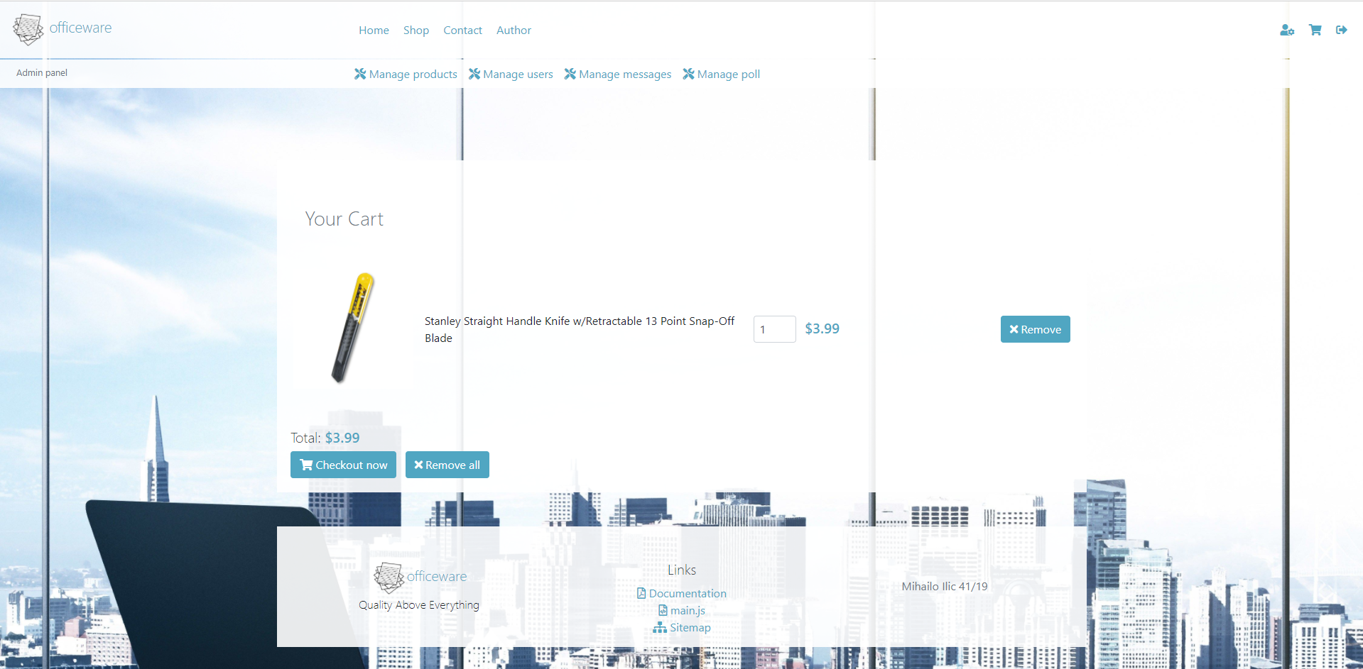

Na ovoj stranici se vidi sadržaj korpe korisnika (ako nema proizvoda u korpi onda se izdaje takva poruka).

Sadržaj se čita iz baze preko AJAX-a, a preko njega se realizuju i sve ostale funkcionalnosti vezane za korpu, kao što je brisanje ili izmena količine.

### 2.3.7 account.php

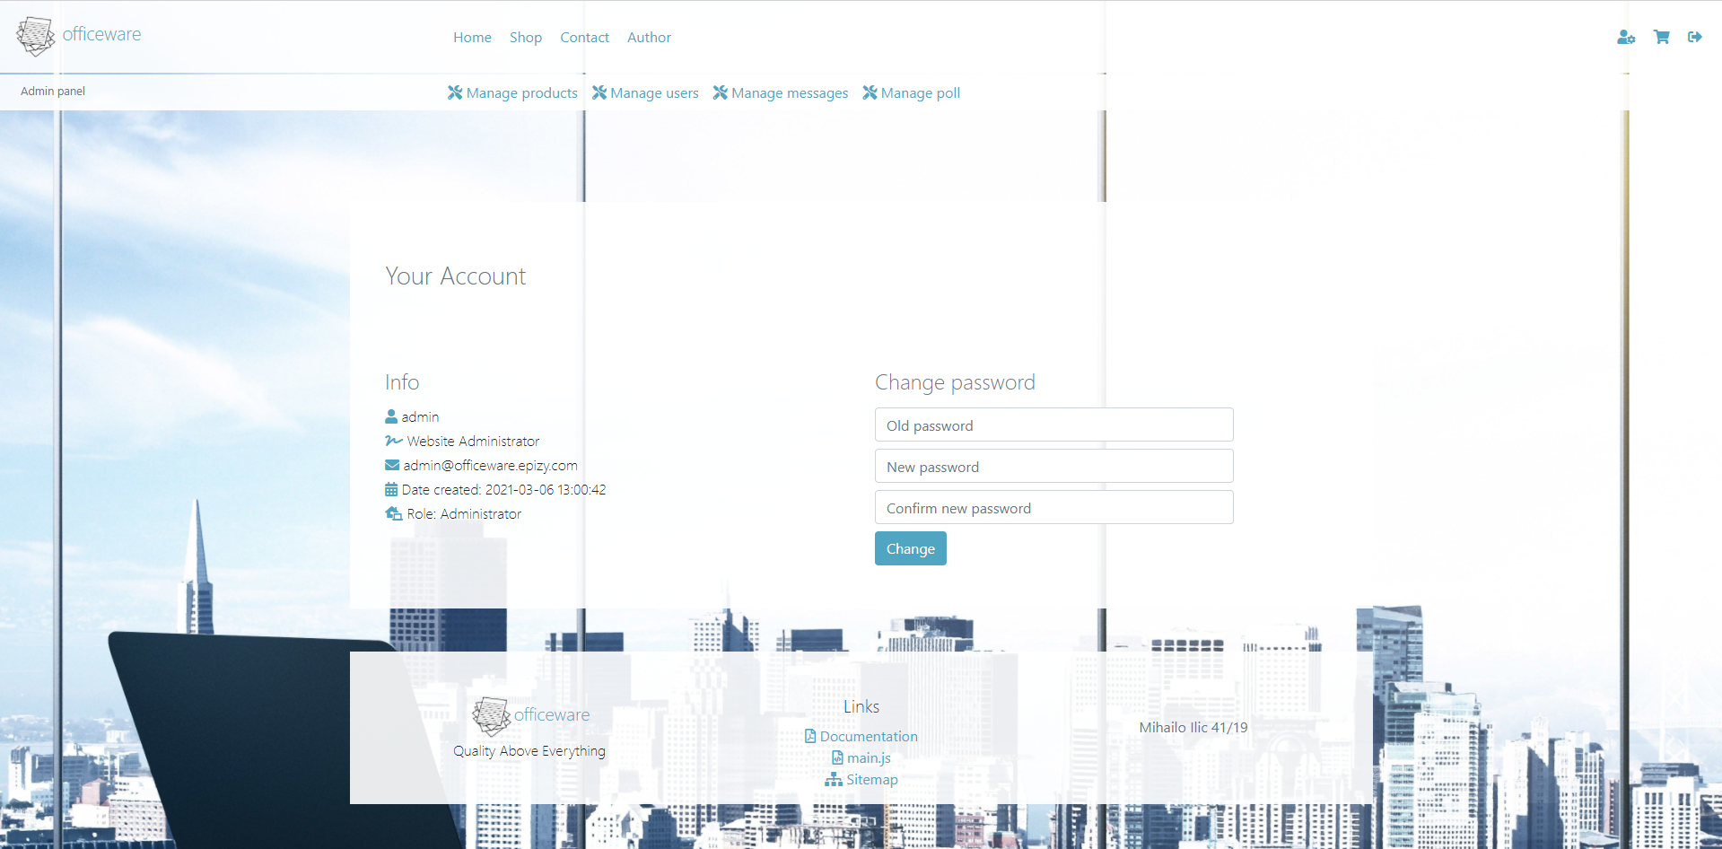

Na ovoj stranici ispisuju se informacije o korisničkom nalogu, a korisniku se takođe nudi promena lozinke. Provera se vrši regularnim izrazima na obe strane.

### 2.3.8 poll.php

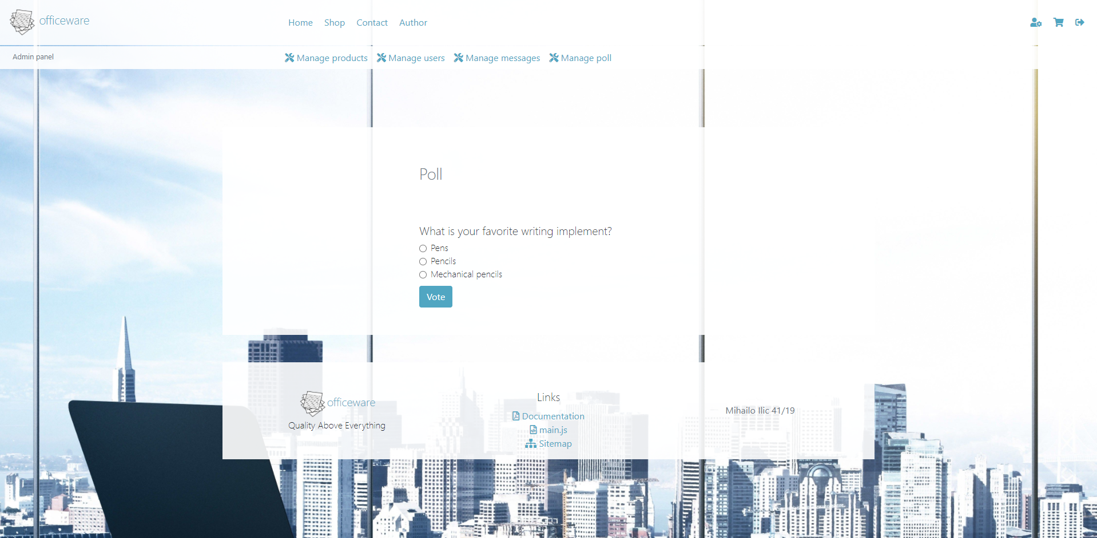

Na ovoj stranici korisnicima je omogućeno da učestvuju u anketi, ali samo jednom (vrši se provera select upitom). Uvid u glasove je moguć samo administratorima.

### 2.3.9 contact.php

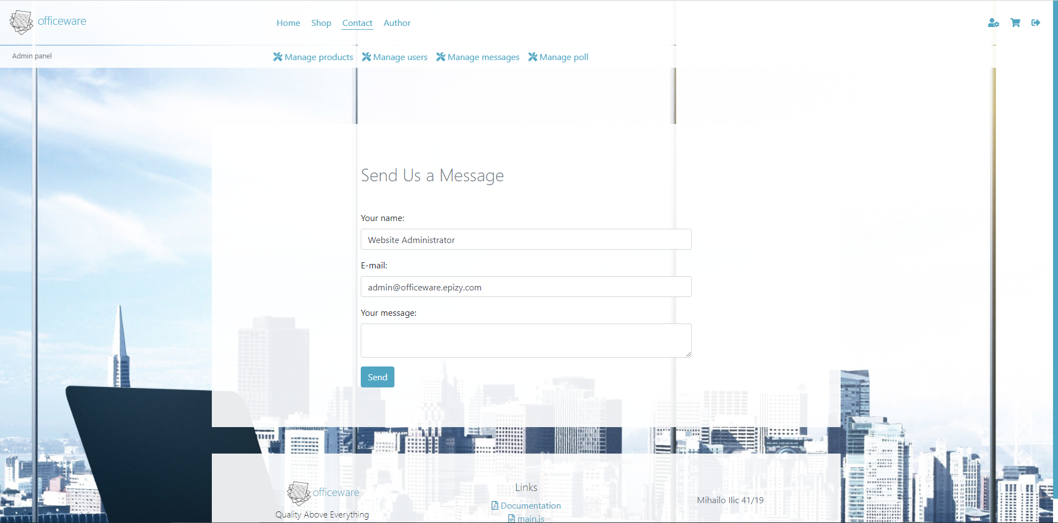

Slanje poruka administratorima sajta moguće je kroz ovu kontakt formu. Ulogovanim korisnicima se automatski popunjavaju ime i imejl adresa. Sadržaj ovih polja proverava se regularnim izrazima na oba kraja.

Administratori poseduju posebnu stranicu za pregled ovih poruka.

### 2.3.10 author.php

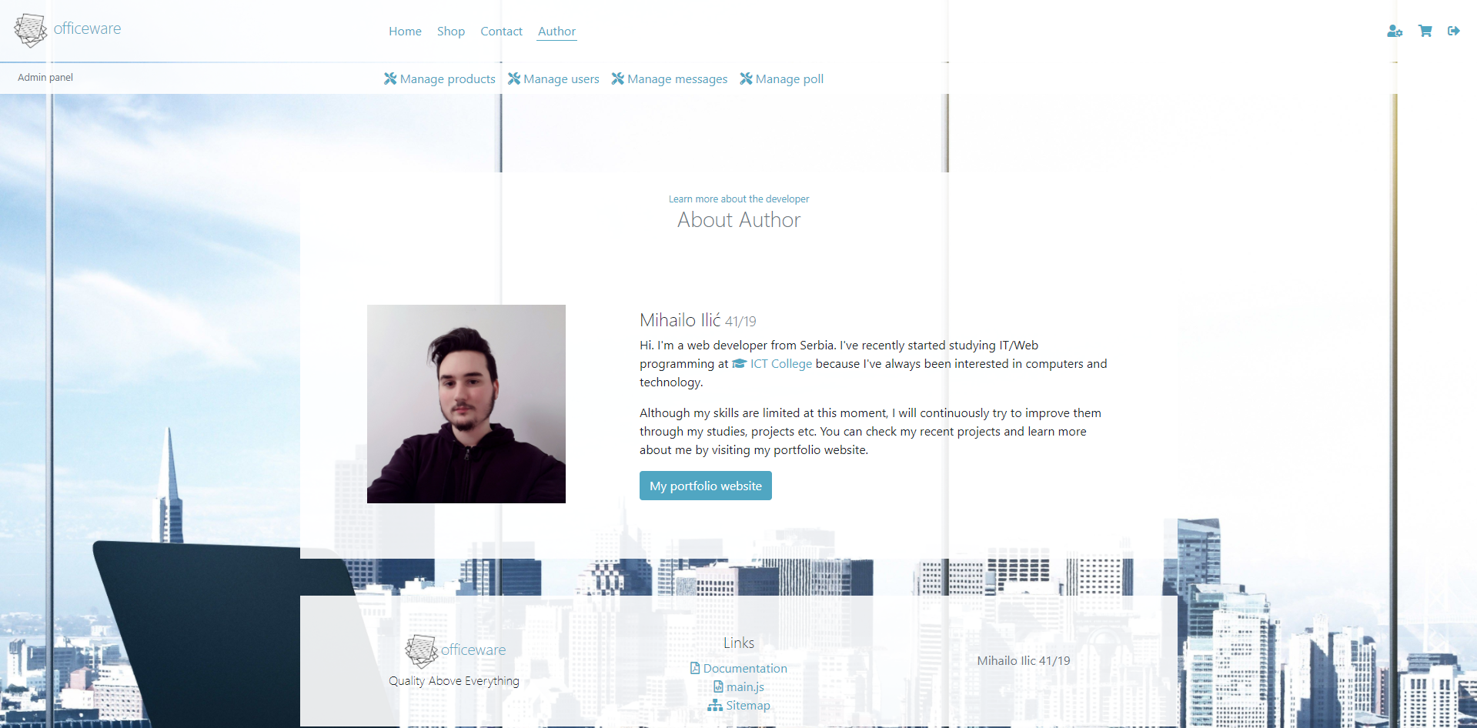

Ne postoji nikakva posebna funkcionalnost na ovoj stranici.

### 2.3.11 admin-products.php

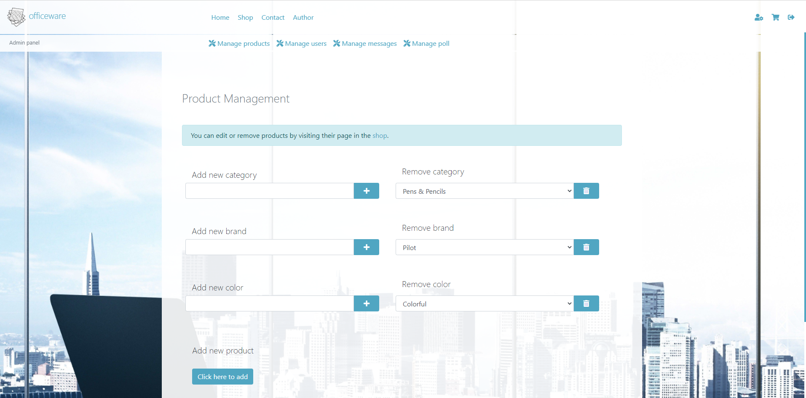

Ova stranica, kao i sve naredne, namenjena je administratoru. Svaki neautorizovani pristup preko URL adrese sprečava se redirekcijom ka stranici index.php.

Ovde se mogu dodati nove kategorije, brendovi i boje, a pored se nalaze popunjene dropdown liste za brisanje istih (moguće samo ako se ne nalaze ni na jednom proizvodu).

Klikom na dugme za dodavanje proizvoda odlazi se na stranicu admin-product-edit.php.

Za izmenjivanje i brisanje proizvoda neophodno je locirati ih u prodavnici (što je ujedno i lakše, jer postoje opcije za filtriranje i pretragu).

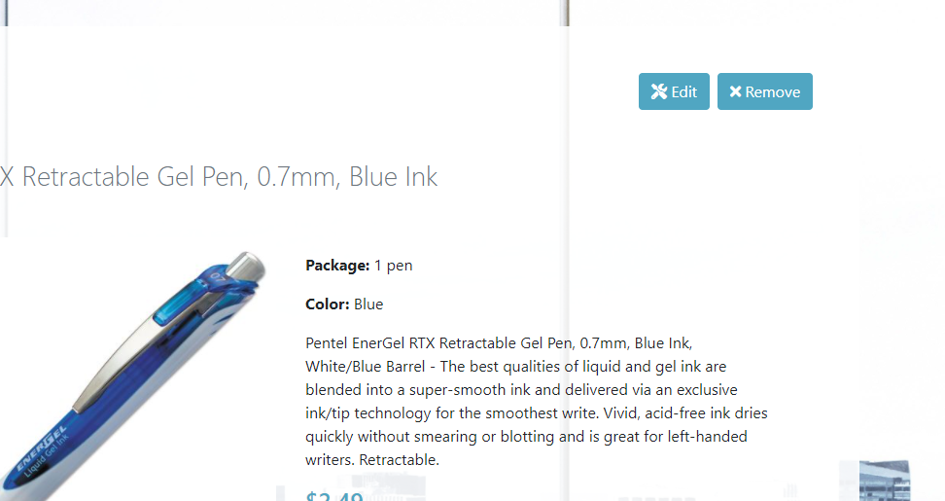

### 2.3.12 admin-product-edit.php

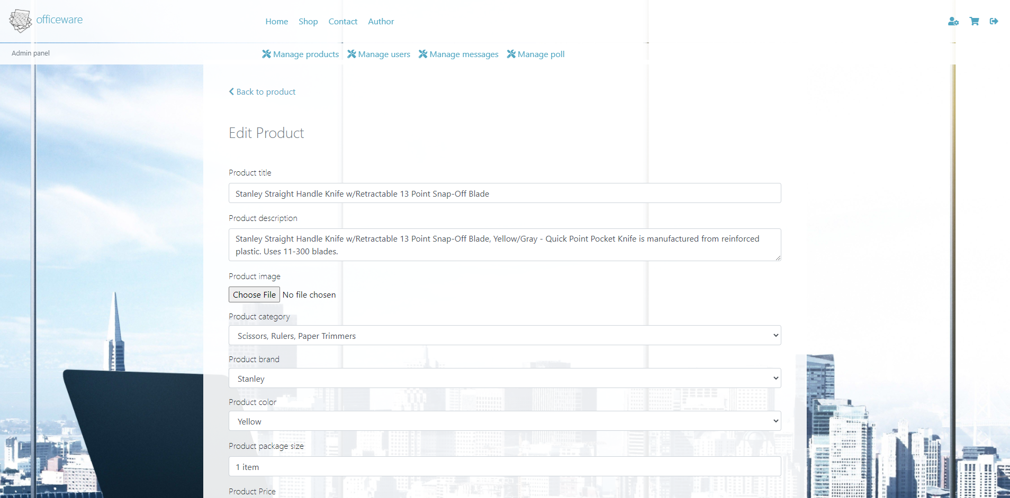 

Na ovoj stranici administratori mogu izmenjivati ili dodati novi proizvod, a ta operacija je upisana u GET superglobalnu promenljivu.

Ako se proizvod izmenjuje onda su sva polja već popunjena pa samo treba promeniti željenu stavku i nije neophodno uploadovati sliku (što je obavezno za nove proizvode).

Sva validacija se vrši regularnim izrazima na obe strane i informacije se upisuju u bazu pomoću bindParam, nad kojim je prethodno izvršena funkcija addslashes.

### 2.3.13 admin-users.php

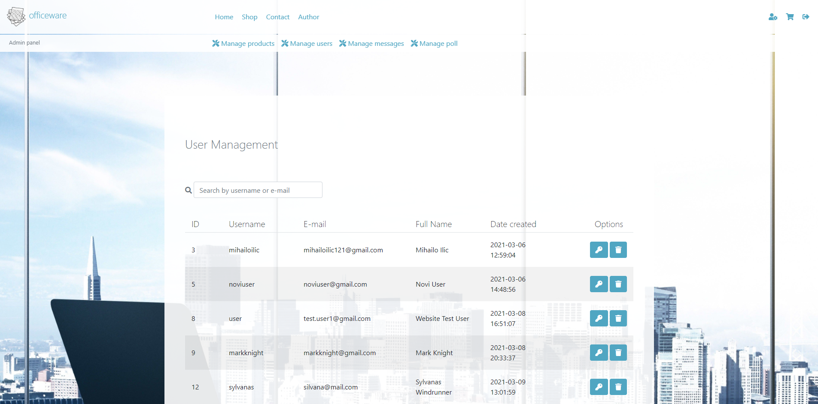

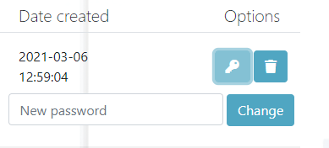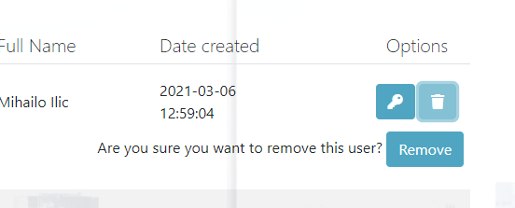

Na ovoj stranici administratori mogu da vide informacije o svim nalozima koji nisu administratorski, i da vrše pretragu istih preko korisničkog imena ili imejl adrese.

Takođe su ponuđene opcije za jednostavnu promenu lozinke i brisanje naloga.

### 2.3.14 admin-messages.php

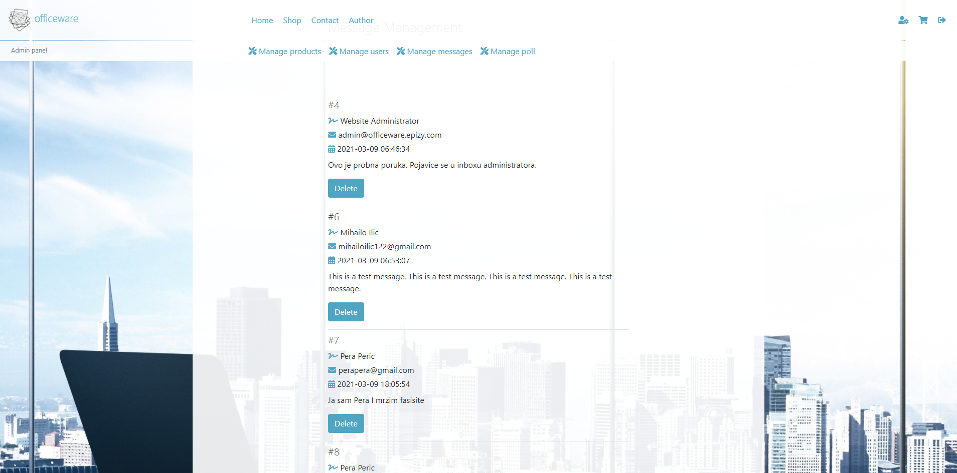

Na ovoj stanici administratorima se prikazuju sve poruke poslate kroz kontakt formu, zajedno sa datumom slanja i opcijom brisanja konkretne poruke.

### 2.3.15 admin-poll.php

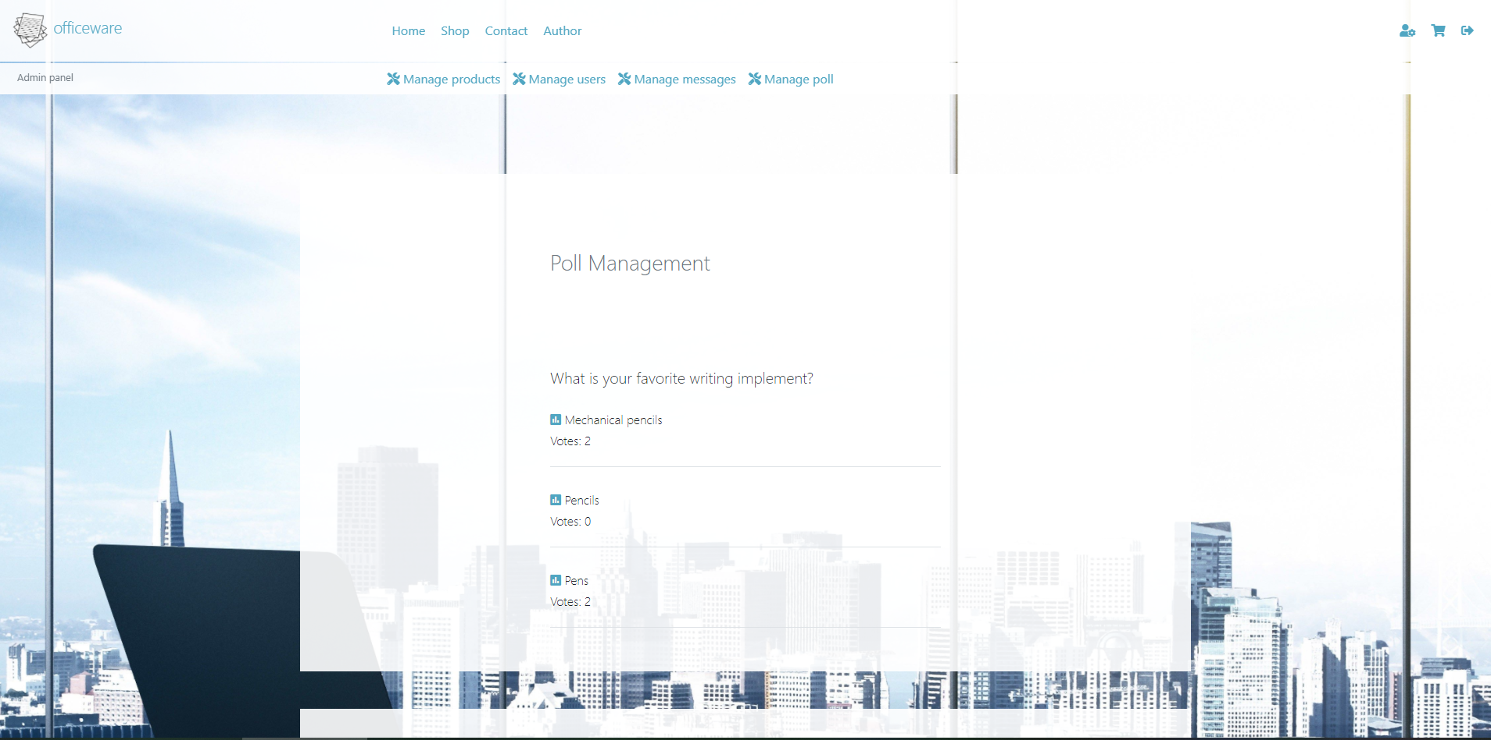

Na ovoj stranici administratori imaju uvid u to koliko je ljudi glasalo za koju opciju iz ankete.

# 3. Kodovi

## 3.1 PHP

### 3.1.1 index.php

<?php

    require_once("config/connection.php");

    require_once("models/session.php");

    require_once("models/functions.php");

    require_once("views/head.php");

    require_once("views/nav.php");

?>

    <main id="home" class="container-fluid position-relative bg-light-trans mx-auto p-0 pb-5">

        <section id="slider-wrapper" class="overflow-hidden position-relative d-flex justify-content-center align-items-center">

            <div id="hero" class="position-absolute w-100 d-flex flex-column justify-content-center align-items-center">

                <h1 class="d-inline">Quality Above Everything</h1>

                <p class="d-inline mt-1">We provide the best office supplies for you. Find everything you need at one place.</p>

                <a href="#visit-shop" class="button p-2 text-white">Learn more</a>

            </div>

            <div id="slider" class="w-100 position-relative d-flex align-items-center">

                <?=getSliderImages()?>

            </div>

        </section>

        <section id="visit-shop" class="p-4 mt-5 pt-5 text-center">

            <span class="small color-primary">Everything you need</span>

            <h2 class="font-weight-light h3">Online Shop</h2>

            <div class="row mx-0 mt-5 align-items-center">

                <div class="col-12 col-md-6 text-right">

                    <img src="assets/img/visit-shop.png" class="w-50" alt="office-supplies"/>

                </div>

                <div class="col-12 col-md-6">

                    <p class="text-left font-weight-light"><span class="fas fa-shopping-basket"></span> Check out all our products here!<br/> <a href="shop.php" class="btn btn-primary mt-2">Visit shop</a></p>

                </div>

            </div>

        </section>

        <section id="visit-poll" class="p-4 mt-5 text-center">

            <span class="small color-primary">Help us improve</span>

            <h2 class="font-weight-light h3">Take a Poll</h2>

            <div class="row mx-0 mt-5 align-items-center">

                <div class="col-12 col-md-6 text-right">

                    <img src="assets/img/visit-poll.png" class="w-50" alt="poll"/>

                </div>

                <div class="col-12 col-md-6">

                    <?php

                        $fake_poll_button = "";

                        if(!$userObj){

                            $fake_poll_button = "fake-poll-button";

                        }

                    ?>

                    <p class="text-left font-weight-light"><span class="fas fa-poll"></span>

                    What is your favorite writing implement?<br/> <a href="poll.php" class="btn btn-primary mt-2 <?=$fake_poll_button?>">Answer</a></p>

                </div>

            </div>

        </section>

    </main>

<?php

    require_once("views/footer.php");

?>

### 3.1.2 shop.php

<?php

    require_once("config/connection.php");

    require_once("models/session.php");

    require_once("models/functions.php");

    require_once("views/head.php");

    require_once("views/nav.php");

?>

    <main id="shop" class="container-fluid position-relative bg-light-trans mx-auto p-0">

        <section id="shop-image" class="page-image w-100 d-flex flex-column justify-content-center align-items-center">

            <h1 class="d-inline">Shop</h1>

            <h2 class="d-inline mt-1 h5">Find everything you need right here!</h2>

        </section>

        <?php

            if(isset($_GET["error"])){

                echo "<p class='alert alert-danger mt-4 container mx-auto mb-0'>".$_GET["error"]."</p>";

            }

        ?>

        <section id="products-wrapper" class="row mx-auto mt-5 py-4">

            <div id="products-filters" class="col-12 col-sm-5 col-md-4 col-lg-4 col-xl-2 m-0">

                <div class="form-group">

                    <label for="max-price" class="font-weight-light h5">Max. price ($):</label>

                    <input type="text" id="max-price" class="form-control" placeholder="For example: 15"/>

                </div>

                <div>

                    <a href="#!" id="clear-filters"><span class="fas fa-times"></span> Clear all filters</a>&nbsp;

                </div>

                <div class="my-5">

                    <h3 class="h5 font-weight-light">Categories: </h3>

                    <ul id="categories">

                    </ul>

                </div>

                <div class="my-5">

                    <h3 class="h5 font-weight-light">Brands: </h3>

                    <ul id="brands">

                    </ul>

                </div>

                <div class="my-5">

                    <h3 class="h5 font-weight-light">Colors: </h3>

                    <ul id="colors">

                    </ul>

                </div>

            </div>

            <div id="products-panel" class="col-12 col-sm-7 col-md-8 col-lg-8 col-xl-10 m-0">

                <div id="products-grid-options" class="row justify-content-between">

                    <div class="col-12 col-sm-12 col-xl-5 my-2 m-md-none">

                        <span><span class="fas fa-search"></span> Search products:</span>

                        <div class="row m-0">

                            <input type="text" class="form-control col-10" value="" id="search-products" placeholder="Enter keywords here"/>

                            <a href="#!" id="search-products-btn" class="col-2 btn btn-primary"><span class="fas fa-search"></span></a>

                        </div>

                    </div>

                    <div class="col-12 col-sm-6 col-xl-4 my-2 m-md-none">

                        <span><span class="fas fa-sort"></span> Sort by:</span>

                        <select class="form-control" id="sort-products">

                            <option value="product_price asc">Price ascending</option>

                            <option value="product_price desc">Price descending</option>

                            <option value="product_title asc">Name ascending</option>

                            <option value="product_title desc">Name descending</option>

                          </select>

                    </div>

                    <div class="col-12 col-sm-6 col-xl-3 my-2 m-md-none">

                        <span><span class="fas fa-layer-group"></span> Pagination:</span>

                        <select class="form-control" id="paginate-products">

                            <option value="0">None</option>

                            <option value="12" selected="selected">12 products per page</option>

                            <option value="24">24 products per page</option>

                          </select>

                    </div>

                </div>

                <div id="products-grid" class="row m-0 mt-4">

                </div>

                <div id="pagination" class="mt-5 text-center">

                </div>

            </div>

        </section>

    </main>

<?php

    require_once("views/footer.php");

?>

### 3.1.3 product.php

<?php

    if(!isset($_GET["id"])){

        header("Location: index.php");

        die();

    }

    require_once("config/connection.php");

    require_once("models/session.php");

    require_once("models/functions.php");

    require_once("views/head.php");

    require_once("views/nav.php");

?>

    <main id="product" class="container position-relative bg-light-trans mx-auto p-5 mb-5">

        <a href="shop.php" class="m-2 d-inline-block"><span class="fas fa-chevron-left"></span> Back to shop</a>

        <?php

            if($userObj && $userObj->role_name == "Administrator"):

        ?>

            <a href="models/delete-data.php?type=products&id=<?=$_GET["id"]?>" class="btn btn-primary text-right float-right ml-2"><span class="fas fa-times"></span> Remove</a>

            <a href="admin-product-edit.php?operation=Edit&id=<?=$_GET["id"]?>" class="btn btn-primary text-right float-right"><span class="fas fa-tools"></span> Edit</a>

        <?php

            endif;

        ?>

        <h1 id="product-name" data-product-id=<?=$_GET["id"]?> class="text-muted my-5 font-weight-light h3 mx-auto">

        </h1>

        <div id="product-wrapper" class="row container-fluid">

            <div class="col12 col-md-6">

                <img src="assets/img/logo.png" alt = "Product Image" id="product-image" class="img-fluid" />

            </div>

            <div class="col12 col-md-6 mt-3">

                <p>

                    <span class="font-weight-bold">Package: </span>

                    <span id="product-package"></span>

                </p>

                <p>

                    <span class="font-weight-bold">Color: </span>

                    <span id="product-color"></span>

                </p>

                <p id="product-description"></p>

                <p class="color-primary h4" id="product-price"><p>

                <div>

                    <?php

                        $fake_cart = "-fake";

                        if($userObj){

                            $fake_cart = "";

                        }

                    ?>

                    <a href="#!" id="add-to-cart<?=$fake_cart?>" data-product-id=<?=$_GET["id"]?> class="btn btn-primary align-top">Add to cart</a>

                    <input type="number" id="add-to-cart-quantity" class="pl-2 pr-0 form-control d-inline-block" value="1" min="1", max="99" onchange="if (this.value<1) {this.value=1;} if(this.value>99){this.value=99;}"/>

                </div>

            </div>

        </div>

    </main>

<?php

    require_once("views/footer.php");

?>

### 3.1.4 login.php

<?php

    require_once("config/connection.php");

    require_once("models/session.php");

    require_once("models/functions.php");

    require_once("views/head.php");

    require_once("views/nav.php");

?>

    <main id="login" class="container position-relative bg-light-trans mx-auto p-4 mb-5">

        <h1 class="text-muted my-5 font-weight-light h2 mx-auto">

            Login

        </h1>

        <form id="login-form" class="mx-auto my-5" name="loginForm" method="post" action="models/login.php">

            <div class="form-group">

                <label for="username">Username:</label>

                <input type="text" name="username" id="username" data-title="username" class="form-control"/>

            </div>

            <div class="form-group">

                <label for="username">Password:</label>

                <input type="password" name="password" id="password" data-title="password" class="form-control"/>

            </div>

            <input type="submit" value="Login" name="btn-login" class="btn btn-primary"/>

        </form>

        <?php

            if(isset($_GET["error"])){

                echo "<p class='alert alert-danger mt-3 mx-auto'>".$_GET["error"]."</p>";

            }

            if(isset($_GET["message"])){

                echo "<p class='alert alert-info mt-3 mx-auto'>".$_GET["message"]."</p>";

            }

        ?>

    </main>

<?php

    require_once("views/footer.php");

?>

### 3.1.5 register.php

<?php

    require_once("config/connection.php");

    require_once("models/session.php");

    require_once("models/functions.php");

    require_once("views/head.php");

    require_once("views/nav.php");

?>

    <main id="register" class="container position-relative bg-light-trans mx-auto p-4 mb-5">

        <?php

            if(isset($_GET["message"])){

                echo "<p class='alert alert-info mt-3 mx-auto'>".$_GET["message"]."</p>";

            }

        ?>

        <h1 class="text-muted my-5 font-weight-light h2 mx-auto">

            Registration

        </h1>

        <form id="register-form" class="mx-auto my-5" name="registerForm" method="post" action="models/registration.php">

            <div class="form-group">

                <label for="full-name">Full Name:</label>

                <input type="text" name="full-name" id="full-name" data-title="full name" class="form-control"/>

            </div>

            <div class="form-group">

                <label for="email">E-mail:</label>

                <input type="text" name="email" id="email" data-title="e-mail" class="form-control"/>

            </div>

            <div class="form-group">

                <label for="username">Username:</label>

                <input type="text" name="username" id="username" data-title="username" class="form-control"/>

            </div>

            <div class="form-group">

                <label for="password">Password:</label>

                <input type="password" name="password" id="password" data-title="password" class="form-control"/>

            </div>

            <div class="form-group">

                <label for="password-repeat">Confirm password:</label>

                <input type="password" name="password-repeat" id="password-repeat" data-title="password repeat" class="form-control"/>

            </div>

            <input type="submit" value="Register" name="btn-register" class="btn btn-primary"/>

        </form>

        <?php

            if(isset($_GET["error"])){

                echo "<p class='alert alert-danger mt-3 mx-auto register-error'>".$_GET["error"]."</p>";

            }

        ?>

    </main>

<?php

    require_once("views/footer.php");

?>

### 3.1.6 account.php

<?php

    require_once("config/connection.php");

    require_once("models/session.php");

    if(!$userObj){

        header("Location: index.php");

        die();

    }

    require_once("models/functions.php");

    require_once("views/head.php");

    require_once("views/nav.php");

?>

    <main id="account" class="container position-relative bg-light-trans py-3 mb-5">

        <h1 class="text-muted my-5 font-weight-light h3 px-4">Your Account</h1>

        <section id="account-panel" class="row p-4 h6 font-weight-light">

            <div id="account-info" class="col-12 col-md-6">

                <h2 class="text-muted my-3 font-weight-light h4">Info</h2>

                <div class="my-2">

                    <span class="fas fa-user color-primary"></span> <?=$userObj->username?>

                </div>

                <div class="my-2">

                    <span class="fas fa-signature color-primary"></span> <?=$userObj->full_name?>

                </div>

                <div class="my-2">

                    <span class="fas fa-envelope color-primary"></span> <?=$userObj->email?>

                </div>

                <div class="my-2">

                    <span class="fas fa-calendar-alt color-primary"></span> Date created: <?=$userObj->date_created?>

                </div>

                <div class="my-2">

                    <span class="fas fa-laptop-house color-primary"></span> Role: <?=$userObj->role_name?>

                </div>

            </div>

            <div id="change-pw-wrapper" class="col-12 col-md-6">

                <h2 class="text-muted my-3 font-weight-light h4">Change password</h2>

                <form name="change-pw" id="change-pw" action="models/user-change-pw.php" method="post">

                    <input type="password" name="old-pw" id="old-pw" class="form-control my-2" placeholder="Old password" data-title="old password"/>

                    <input type="password" name="new-pw" id="new-pw" class="form-control my-2" placeholder="New password" data-title="new password"/>

                    <input type="password" name="confirm-pw" id="confirm-pw" class="form-control my-2" placeholder="Confirm new password" data-title="password confirmation"/>

                    <button type="submit" id="btn-change-pw" name="btn-change-pw" class="btn btn-primary">Change</button>

                </form>

                <?php

                    if(isset($_GET["error"])){

                        echo "<p class='alert alert-danger mt-3'>".$_GET["error"]."</p>";

                    }

                    if(isset($_GET["message"])){

                    echo "<p class='alert alert-info mt-3'>".$_GET["message"]."</p>";

                    }

                ?>

            </div>

        </section>

    </main>

<?php

    require_once("views/footer.php");

?>

### 3.1.7 cart.php

<?php

    require_once("config/connection.php");

    require_once("models/session.php");

    if(!$userObj){

        header("Location: index.php");

        die();

    }

    require_once("models/functions.php");

    require_once("views/head.php");

    require_once("views/nav.php");

?>

    <main id="cart" class="container position-relative bg-light-trans py-3 mb-5">

        <h1 class="text-muted my-5 font-weight-light h3 px-4">Your Cart</h1>

        <div id="cart-items">

        </div>

    </main>

<?php

    require_once("views/footer.php");

?>

### 3.1.8 contact.php

<?php

    require_once("config/connection.php");

    require_once("models/session.php");

    require_once("models/functions.php");

    require_once("views/head.php");

    require_once("views/nav.php");

    $name = "";

    $email = "";

    if($userObj){

        $name = $userObj->full_name;

        $email = $userObj->email;

    }

?>

    <main id="contact" class="container position-relative bg-light-trans mx-auto p-4 mb-5">

        <h1 class="text-muted my-5 font-weight-light h2 mx-auto">

            Send Us a Message

        </h1>

        <form id="contact-form" class="mx-auto my-5" name="contact-form" method="post" action="models/send-message.php">

            <div class="form-group">

                <label for="name">Your name:</label>

                <input type="text" name="name" id="name" data-title="name" class="form-control" value="<?=$name?>"/>

            </div>

            <div class="form-group">

                <label for="username">E-mail:</label>

                <input type="text" name="email" id="email" data-title="e-mail" class="form-control" value="<?=$email?>"/>

            </div>

            <div class="form-group">

                <label for="username">Your message:</label>

                <textarea class="form-control" id="message" name="message" data-title="message"></textarea>

            </div>

            <input type="submit" value="Send" name="btn-send" id="btn-send" class="btn btn-primary"/>

        </form>

        <?php

            if(isset($_GET["error"])){

                echo "<p class='alert alert-danger mt-3 mx-auto'>".$_GET["error"]."</p>";

            }

            if(isset($_GET["message"])){

                echo "<p class='alert alert-info mt-3 mx-auto'>".$_GET["message"]."</p>";

            }

        ?>

    </main>

<?php

    require_once("views/footer.php");

?>

### 3.1.9 author.php

<?php

    require_once("config/connection.php");

    require_once("models/session.php");

    require_once("models/functions.php");

    require_once("views/head.php");

    require_once("views/nav.php");

?>

    <main id="author" class="container position-relative bg-light-trans mx-auto p-4 mb-5">

        <span class="small color-primary text-center w-100 d-block">Learn more about the developer</span>

        <h1 class="text-muted mb-5 font-weight-light h3 px-4 text-center">About Author</h1>

        <section id="author-data" class="row container mx-auto justify-content-center align-items-center">

            <div id="author-portrait" class="col-10 col-md-4 p-5 p-md-2 p-lg-5">

                <img src="assets/img/author-portrait.jpg" class="img-fluid" alt="Author"/>

            </div>

            <div id="author-info" class="col-12 col-md-8 p-5">

                <h4 class="font-weight-light h4">Mihailo Ilić<small class="text-muted font-weight-light"> 41/19</small></h4>

                <p>Hi. I'm a web developer from Serbia. I've recently started studying IT/Web programming at <a href="https://ict.edu.rs/" class="primary-color" target="_blank"><span class="fa fa-graduation-cap"></span> ICT College</a> because I've always been interested in computers and technology.</p>

                <p>Although my skills are limited at this moment, I will continuously try to improve them through my studies, projects etc. You can check my recent projects and learn more about me by visiting my portfolio website.</p>

                <a href="https://mihailoilic.github.io/portfolio/" target="_blank" class="btn btn-primary text-center">My portfolio website</a>

            </div>

        </section>

    </main>

<?php

    require_once("views/footer.php");

?>

### 3.1.10 poll.php

<?php

    require_once("config/connection.php");

    require_once("models/session.php");

    if(!$userObj){

        header("Location: index.php");

        die();

    }

    require_once("models/functions.php");

    require_once("views/head.php");

    require_once("views/nav.php");

?>

    <main id="poll" class="container position-relative bg-light-trans py-3 mb-5">

        <h1 class="text-muted my-5 mx-auto font-weight-light h3 px-4">Poll</h1>

        <?php

        if(isset($_GET["error"])){

                echo "<p class='alert alert-danger mt-3 mx-auto'>".$_GET["error"]."</p>";

        }

        if(isset($_GET["message"])){

            echo "<p class='alert alert-info mt-3 mx-auto'>".$_GET["message"]."</p>";

        }

        ?>

        <section id="poll" class="p-4 h6 font-weight-light mx-auto">

            <h2 class="font-weight-light h5">What is your favorite writing implement?</h2>

            <?php

                if(!checkParticipation($userObj->user_id)):

                    $choices = selectQuery("poll_choices");

                    echo '<form name="poll" action="models/poll-vote.php" method="post">';

                    foreach($choices as $choice):

            ?>

                <div class="form-check my-1">

                    <input class="form-check-input" type="radio" name="poll-choice" id="poll-choice-<?=$choice->choice_id?>" value="<?=$choice->choice_id?>">

                    <label class="form-check-label" for="poll-choice-<?=$choice->choice_id?>">

                        <?=$choice->choice_title?>

                    </label>

                </div>

            <?php

                    endforeach;

                    echo '<input type="submit" value="Vote" class="btn btn-primary mt-2" name="btn-vote" id="btn-vote"/></form>';

                else:

            ?>

                <p class="p-3"><span class="fas fa-check color-primary"></span>  You have already voted.</p>

            <?php

                endif;

            ?>

        </section>

    </main>

<?php

    require_once("views/footer.php");

?>

### 3.1.11 admin-products.php

<?php

    require_once("config/connection.php");

    require_once("models/session.php");

    if(!($userObj && $userObj->role_name == "Administrator")){

        header("Location: index.php");

        die();

    }

    require_once("models/functions.php");

    require_once("views/head.php");

    require_once("views/nav.php");

    $categories = selectQuery("categories");

    $brands = selectQuery("brands");

    $colors = selectQuery("colors");

?>

    <main id="admin-products" class="container position-relative bg-light-trans mx-auto p-5 mb-5">

        <h1 class="text-muted my-5 font-weight-light h3 mx-auto">

            Product Management

        </h1>

        <p class="alert alert-info mt-3 mx-auto">You can edit or remove products by visiting their page in the <a href="shop.php">shop</a>.</p>

        <div class="row container-fluid mt-5">

            <div class="col-12 col-md-6 p-0 p-md-2">

                <div class="row m-0">

                    <h2 class="h5 font-weight-light col-12">Add new category</h2>

                    <input type="text" id="new-category" class="col-8 col-sm-9 col-lg-10 form-control d-inline max-width-400" />

                    <button type="button" id="new-category-btn" data-type="categories" class="btn btn-primary align-baseline col-4 col-sm-3 col-lg-2"><span class="fas fa-plus"></span></button>

                </div>

            </div>

            <div class="col-12 col-md-6 p-0 row m-0 mt-2 mt-md-0">

                <h2 class="h5 font-weight-light col-12">Remove category</h2>

                <select name="categories" id="categories" class="form-control col-8 col-sm-9 col-lg-10"></select>

                <button type="button" id="remove-category-btn" data-type="categories" class="btn btn-primary align-baseline col-4 col-sm-3 col-lg-2 py-0"><span class="fas fa-trash-alt"></span></button>

            </div>

        </div>

        <div class="row container-fluid mt-5">

            <div class="col-12 col-md-6 p-0 p-md-2">

                <div class="row m-0">

                    <h2 class="h5 font-weight-light col-12">Add new brand</h2>

                    <input type="text" id="new-brand" class="col-8 col-sm-9 col-lg-10 form-control d-inline max-width-400" />

                    <button type="button" id="new-brand-btn" data-type="brands" class="btn btn-primary align-baseline col-4 col-sm-3 col-lg-2"><span class="fas fa-plus"></span></button>

                </div>

            </div>

            <div class="col-12 col-md-6 p-0 row m-0 mt-2 mt-md-0">

                <h2 class="h5 font-weight-light col-12">Remove brand</h2>

                <select name="brands" id="brands" class="form-control col-8 col-sm-9 col-lg-10"></select>

                <button type="button" id="remove-brand-btn" data-type="brands" class="btn btn-primary align-baseline col-4 col-sm-3 col-lg-2 py-0"><span class="fas fa-trash-alt"></span></button>

            </div>

        </div>

        <div class="row container-fluid mt-5">

            <div class="col-12 col-md-6 p-0 p-md-2">

                <div class="row m-0">

                    <h2 class="h5  font-weight-light col-12">Add new color</h2>

                    <input type="text" id="new-color" class="col-8 col-sm-9 col-lg-10 form-control d-inline max-width-400" />

                    <button type="button" id="new-color-btn" data-type="colors" class="btn btn-primary align-baseline col-4 col-sm-3 col-lg-2"><span class="fas fa-plus"></span></button>

                </div>

            </div>

            <div class="col-12 col-md-6 p-0 row m-0 mt-2 mt-md-0">

                <h2 class="h5 font-weight-light col-12">Remove color</h2>

                <select name="colors" id="colors" class="form-control col-8 col-sm-9 col-lg-10"></select>

                <button type="button" id="remove-color-btn" data-type="colors" class="btn btn-primary align-baseline col-4 col-sm-3 col-lg-2 py-0"><span class="fas fa-trash-alt"></span></button>

            </div>

    </div>

    <h2 class="h5 mt-5 p-4 font-weight-light">Add new product</h2>

    <p><a href="admin-product-edit.php?operation=New" class="ml-4 btn btn-primary">Click here to add</a></p>

    </main>

<?php

    require_once("views/footer.php");

?>

### 3.1.12 admin-product-edit.php

<?php

    require_once("config/connection.php");

    require_once("models/session.php");

    if(!($userObj && $userObj->role_name == "Administrator")){

        header("Location: index.php");

        die();

    }

    require_once("models/functions.php");

    require_once("views/head.php");

    require_once("views/nav.php");

    if(isset($_GET["operation"])){

        $operation = $_GET["operation"];

    }

    else {

        header("Location: index.php");

        die();

    }

    $categories = selectQuery("categories");

    $brands = selectQuery("brands");

    $colors = selectQuery("colors");

    if($operation == "Edit"){

        $id = $_GET["id"];

        $product = selectQuery("products WHERE product_id = $id")[0];

    }

?>

    <main id="admin-product-edit" class="container position-relative bg-light-trans mx-auto p-5 mb-5">

        <?php

            if(isset($_GET["success"])){

                echo '<p class="alert alert-info mt-3 mx-auto">Product successfully added. You can view it <a href="product.php?id='.$_GET["success"].'">here</a>.</p>';

            }

            if(isset($_GET["error"])){

                echo '<p class="alert alert-danger mt-3 mx-auto">'.$_GET["error"].'</p>';

            }

            if($operation == "Edit"):

        ?>

            <a href="product.php?id=<?=$product->product_id?>"><span class="fas fa-chevron-left"></span> Back to product</a>

        <?php

            endif;

        ?>

        <h1 class="text-muted my-5 font-weight-light h3 mx-auto">

            <?=$operation?> Product

        </h1>

        <form method="POST" action="models/insert-data.php" enctype="multipart/form-data">

            <input type="hidden" id="product-operation" name="operation" value="<?=$operation?>"/>

            <input type="hidden" name="type" value="products"/>

            <?php

                if($operation == "Edit"):

            ?>

                <input type="hidden" name="id" value="<?=$id?>" />

            <?php

                endif;

            ?>

            <div class="form-group">

                <label for="product-title" class="font-weight-light">Product title</label>

                <input type="text" data-title="title" class="form-control" id="product-title" name="product-title" value="<?=$operation == "Edit" ? $product->product_title : ""?>"/>

            </div>

            <div class="form-group mt-3">

                <label for="product-description" class="font-weight-light">Product description</label>

                <textarea type="text" data-title="description" class="form-control" id="product-description" name="product-description"><?=$operation == "Edit" ? $product->product_description : ""?></textarea>

            </div>

            <div class="form-group">

                <label for="product-image" class="font-weight-light">Product image</label><br/>

                <input type="file" class="" id="product-image" name="product-image" />

            </div>

            <?php

                echo '<div class="form-group mt-2">

                <h3 class="font-weight-light h6">Product category</h3>

                <select name="category" class="form-control">';

                foreach($categories as $cat){

                    $selected = "";

                    if($operation == "Edit" && $cat->category_id == $product->category_id){

                        $selected = "selected = 'selected'";

                    }

                    echo "<option value='$cat->category_id' $selected>$cat->category_name</option>";

                }

                echo '</select></div>';

                echo '<div class="form-group mt-3">

                <h3 class="font-weight-light h6">Product brand</h3>

                <select name="brand" class="form-control">';

                foreach($brands as $brand){

                    $selected = "";

                    if($operation == "Edit" && $brand->brand_id == $product->brand_id){

                        $selected = "selected = 'selected'";

                    }

                    echo "<option value='$brand->brand_id' $selected>$brand->brand_name</option>";

                }

                echo '</select>';

                echo '<div class="form-group mt-3">

                <h3 class="font-weight-light h6">Product color</h3>

                <select name="color" class="form-control">';

                foreach($colors as $color){

                    $selected = "";

                    if($operation == "Edit" && $color->color_id == $product->color_id){

                        $selected = "selected = 'selected'";

                    }

                    echo "<option value='$color->color_id' $selected>$color->color_name</option>";

                }

                echo '</select>';

            ?>

            <div class="form-group mt-3">

                <label for="product-package" class="font-weight-light">Product package size</label>

                <input type="text" data-title="package size" class="form-control" id="product-package" name="product-package" value="<?=$operation == "Edit" ? $product->package_size : ""?>"/>

            </div>

            <div class="form-group">

                <label for="product-price" class="font-weight-light">Product Price</label>

                <input type="text" data-title="price" class="form-control" id="product-price" name="product-price" placeholder="For example: 19.99" value="<?=$operation == "Edit" ? $product->product_price : ""?>"/>

            </div>

            <button type="sumbit" class="btn btn-primary" id="btn-submit" name="btn-submit">Submit</button>

        </form>

    </main>

<?php

    require_once("views/footer.php");

?>

### 3.1.13 admin-users.php

<?php

    require_once("config/connection.php");

    require_once("models/session.php");

    if(!($userObj && $userObj->role_name == "Administrator")){

        header("Location: index.php");

        die();

    }

    require_once("models/functions.php");

    require_once("views/head.php");

    require_once("views/nav.php");

?>

    <main id="admin-users" class="container-lg position-relative bg-light-trans mx-auto p-5 mb-5">

        <h1 class="text-muted my-5 pb-4 font-weight-light h3 mx-auto">

            User Management

        </h1>

        <span class="fas fa-search text-muted"></span>

        <input type="text" id="search-users" class="form-control d-inline" placeholder="Search by username or e-mail" />

        <div id="users-wrapper" class="containter-fluid pt-5">

            <div class="user-info row m-0 border-bottom">

                <div class="col-1 user-id h5 font-weight-light">ID</div>

                <div class="col-2 username h5 font-weight-light">Username</div>

                <div class="col-3 user-email h5 font-weight-light">E-mail</div>

                <div class="col-2 user-full-name h5 font-weight-light">Full Name</div>

                <div class="col-2 user-date-created h5 font-weight-light">Date created</div>

                <div class="col-2 h5 font-weight-light text-right pr-4">Options</div>

            </div>

            <div id="users">

            </div>

        </div>

    </main>

<?php

    require_once("views/footer.php");

?>

### 3.1.14 admin-messages.php

<?php

    require_once("config/connection.php");

    require_once("models/session.php");

    if(!($userObj && $userObj->role_name == "Administrator")){

        header("Location: index.php");

        die();

    }

    require_once("models/functions.php");

    require_once("views/head.php");

    require_once("views/nav.php");

    $messages = selectQuery("messages");

?>

    <main id="admin-messages" class="container-lg position-relative bg-light-trans mx-auto p-5 mb-5">

        <h1 class="text-muted my-5 pb-4 font-weight-light h3 mx-auto">

            Message Management

        </h1>

        <?php

                    if(isset($_GET["error"])){

                        echo "<p class='alert alert-danger mt-3 mx-auto'>".$_GET["error"]."</p>";

                    }

                    if(isset($_GET["message"])){

                    echo "<p class='alert alert-info mt-3 mx-auto'>".$_GET["message"]."</p>";

                    }

                ?>

        <div id="messages-wrapper" class="containter-fluid pt-5 mx-auto">

        <?php

            if(Count($messages) > 0):

                foreach($messages as $message):

        ?>

            <div class="message py-2 border-bottom">

                <div class="message-id h5 font-weight-light">#<?=$message->message_id?></div>

                <div class="sender-name my-1"><span class="fas fa-signature color-primary"></span> <?=$message->sender_name?></div>

                <div class="sender-email my-1"><span class="fas fa-envelope color-primary"></span> <?=$message->sender_email?></div>

                <div class="message-date my-1"><span class="fas fa-calendar-alt color-primary"></span> <?=$message->date_sent?></div>

                <div class="message-text my-2"><?=$message->message_text?></div>

                <a href="models/delete-message.php?id=<?=$message->message_id?>" class="btn btn-primary my-2">Delete</a>

            </div>

        <?php

                endforeach;

            else:

        ?>

            <p class="h5 font-weight-light">The inbox is empty.</p>

        <?php

            endif;

        ?>

        </div>

    </main>

<?php

    require_once("views/footer.php");

?>

### 3.1.15 admin-poll.php

<?php

    require_once("config/connection.php");

    require_once("models/session.php");

    if(!($userObj && $userObj->role_name == "Administrator")){

        header("Location: index.php");

        die();

    }

    require_once("models/functions.php");

    require_once("views/head.php");

    require_once("views/nav.php");

    $poll_answers = selectQuery("SELECT choice_title, COUNT(pa.choice_id) AS vote_count FROM poll_answers pa RIGHT OUTER JOIN poll_choices pc ON pa.choice_id = pc.choice_id GROUP BY choice_title", true);

?>

    <main id="admin-poll" class="container-lg position-relative bg-light-trans mx-auto p-5 mb-5">

        <h1 class="text-muted my-5 pb-4 font-weight-light h3 mx-auto">

            Poll Management

        </h1>

        <div id="poll-results" class="containter-fluid pt-5 mx-auto">

            <?php

                if(Count($poll_answers) > 0):

                    echo '<h2 class="font-weight-light h5">What is your favorite writing implement?</h2>';

                    foreach($poll_answers as $answer):

            ?>

                <div class="choice py-3 border-bottom font-weight-light h6">

                    <div class="my-2"><span class="fas fa-poll color-primary"></span> <?=$answer->choice_title?></div>

                    <div class="my-2">Votes: <?=$answer->vote_count?></div>

                </div>

            <?php

                    endforeach;

                else:

            ?>

                <p class="font-weight-light h5">There are no votes yet.</p>

            <?php

                endif;

            ?>

        </div>

    </main>

<?php

    require_once("views/footer.php");

?>

### 3.1.16 config/connection.php

<?php

    define("SERVER", "localhost");

    define("DB", "officeware");

    define("USER", "root");

    define("PW", "");

    try {

        $konekcija = new PDO("mysql:host=".SERVER.";dbname=".DB.";charset=utf8", USER, PW);

        $konekcija->setAttribute(PDO::ATTR_DEFAULT_FETCH_MODE, PDO::FETCH_OBJ);

        $konekcija->setAttribute(PDO::ATTR_ERRMODE, PDO::ERRMODE_EXCEPTION);

    }

    catch (PDOException $c){

        echo "Database connection failed!<br/><br/>".$c->getMessage();

    }

?>

### 3.1.17 models/admin-change-pw.php

<?php

    header("Content-type: application/json");

    require_once("../config/connection.php");

    require_once("session.php");

    require_once("functions.php");

    if($userObj && isset($_POST["role"])){

        $role = $_POST["role"];

        if($role == "Administrator" && $userObj->role_name == "Administrator"){

            $new_pw = md5(addslashes($_POST["new-pw"]));

            $id = $_POST["id"];

            try {

                $rez = changePassword($id, $new_pw);

                if($rez){

                    echo json_encode(["message" => "Password successfully changed."]);

                    http_response_code(200);

                }

                else {

                    echo json_encode(["message" => "Error changing password."]);

                    http_response_code(500);

                }

            }

            catch(PDOException $ex){

                echo json_encode(["message" => $ex->getMessage()]);

                http_response_code(500);

            }

        }

        else {

            echo json_encode(["message" => "Not found."]);

            http_response_code(404);

        }

    }

?>

### 3.1.18 models/cart-operations.php

<?php

    require_once("session.php");

    if($userObj){

        require_once("../config/connection.php");

        require_once("functions.php");

        if(isset($_GET["operation"])){

            $operation = $_GET["operation"];

            if($operation == "add" || $operation == "set"){

                $id = addslashes($_GET["id"]);

                $quantity = addslashes($_GET["quantity"]);

                if($operation == "add" && ((int)$quantity<1 || (int)$quantity > 99)){

                    echo json_encode(["message" => "Error. Quantity is wrong."]);

                    http_response_code(406);

                    die();

                }

                $cartItemExists = selectQuery("cart WHERE user_id = $userObj->user_id AND product_id = $id");

                try{

                    if($cartItemExists){

                        $qtyString = "quantity + ";

                        if($operation == "set"){

                            $qtyString = "";

                        }

                        $updateQuery = $konekcija->prepare("UPDATE cart SET quantity = $qtyString :qty WHERE user_id = :userid AND product_id = :pid");

                        $updateQuery->bindParam(":qty", $quantity);

                        $updateQuery->bindParam(":userid", $userObj->user_id);

                        $updateQuery->bindParam(":pid", $id);

                        $rez = $updateQuery->execute();

                    }

                    else {

                        $insertQuery = $konekcija->prepare("INSERT INTO cart VALUES(:pid, :userid, :qty)");

                        $insertQuery->bindParam(":pid", $id);

                        $insertQuery->bindParam(":userid", $userObj->user_id);

                        $insertQuery->bindParam(":qty", $quantity);

                        $rez = $insertQuery->execute();

                    }

                    if($rez){

                        echo json_encode(["message" => "Successfully added to your cart."]);

                        http_response_code(200);

                    }

                    else{

                        echo json_encode(["message" => "An error occurred. Please try again later."]);

                        http_response_code(500);

                    }

                }

                catch(PDOException $ex){

                    echo json_encode(["message" => "An error occurred. Please try again later.", "errorMessage" => $ex.getMessage()]);

                    http_response_code(500);

                }

            }

            else if($operation == "remove" || $operation == "remove-all"){

                if($operation == "remove"){

                    $id = addslashes($_GET["id"]);

                    $removeIdString = "product_id = $id AND";

                }

                else {

                    $removeIdString = "";

                }

                try{

                    $deleteQuery = $konekcija->prepare("DELETE FROM cart WHERE $removeIdString user_id = :userid");

                    $deleteQuery->bindParam(":userid", $userObj->user_id);

                    $rez = $deleteQuery->execute();

                    if($rez){

                        echo json_encode(["message" => "Successfully removed."]);

                        http_response_code(200);

                    }

                    else{

                        echo json_encode(["message" => "An error occurred. Please try again later."]);

                        http_response_code(500);

                    }

                }

                catch(PDOException $ex){

                    echo json_encode(["message" => "An error occurred. Please try again later.", "errorMessage" => $ex.getMessage()]);

                    http_response_code(500);

                }

            }

        else if($operation == "get"){

            try{

                $cartItems = selectQuery("cart WHERE user_id = $userObj->user_id");

                echo json_encode($cartItems);

                http_response_code(200);

            }

            catch(PDOException $ex){

                echo json_encode(["message" => "An error occurred. Please try again later.", "errorMessage" => $ex.getMessage()]);

                http_response_code(500);

            }

        }

        else {

            echo json_encode(["message" => "Not found."]);

            http_response_code(404);

        }

    }

}

    else {

        header("Location: ../index.php");

    }

?>

### 3.1.18 models/delete-data.php

<?php

    header("Content-type: application/json");

    require_once("../config/connection.php");

    require_once("session.php");

    if(!($userObj && $userObj->role_name == "Administrator")){

        header("Location: ../index.php");

        die();

    }

    if(isset($_GET["type"])){

        $type = $_GET["type"];

        $id = $_GET["id"];

        if($type == "categories" || $type == "brands" || $type == "colors"){

            $column_name = $_GET["column-name"];

            if(Count(selectQuery("products WHERE $column_name = $id"))>0){

                echo json_encode(["message" => "Can't remove this!"]);

                http_response_code(406);

                die();

            }

            try {

                $deleteQuery = $konekcija->prepare("DELETE FROM $type WHERE $column_name = :id");

                $deleteQuery->bindParam(":id", $id);

                $rez = $deleteQuery->execute();

                if($rez){

                    echo json_encode(["message" => "Item successfully removed from $type."]);

                    http_response_code(200);

                }

                else {

                    echo json_encode(["message" => "Error removing item. Try again later."]);

                    http_response_code(500);

                }

            }

            catch(PDOException $ex){

                echo json_encode(["message" => "Error removing item. ".$ex->getMessage()]);

                http_response_code(500);

            }

        }

        else if($type == "products"){

            try {

                $deleteQuery = $konekcija->prepare("DELETE p, c FROM products p LEFT JOIN cart c on p.product_id = c.product_id WHERE p.product_id = :id");

                $deleteQuery->bindParam(":id", $id);

                $rez = $deleteQuery->execute();

                if($rez){

                    header("Location: ../shop.php");

                }

                else {

                    $error = "Error removing product. Try again later.";

                    header("Location: ../shop.php?error=$error");

                }

            }

            catch(PDOException $ex){

                $error = "Error removing product. Try again later.";

                header("Location: ../shop.php?error=$error");

            }

        }

        else if($type == "users"){

            try {

                $deleteQuery = $konekcija->prepare("DELETE FROM users WHERE user_id = :id AND role_id <> 2");

                $deleteQuery->bindParam(":id", $id);

                $rez = $deleteQuery->execute();

                if($rez){

                    echo json_encode(["message" => "User successfully removed."]);

                    http_response_code(200);

                }

                else {

                    echo json_encode(["message" => "Error removing user. Try again later."]);

                    http_response_code(500);

                }

            }

            catch(PDOException $ex){

                echo json_encode(["message" => $ex->getMessage()]);

                http_response_code(500);

            }

        }

        else {

            header("Location: ../index.php");

        }

    }

?>

### 3.1.19 models/delete-message.php

<?php

    require_once("../config/connection.php");

    require_once("session.php");

    if(!($userObj && $userObj->role_name == "Administrator")){

        header("Location: ../index.php");

        die();

    }

    if(isset($_GET["id"])){

        $id = $_GET["id"];

        try {

            $deleteQuery = $konekcija->prepare("DELETE FROM messages WHERE message_id = :id");

            $deleteQuery->bindParam(":id", $id);

            $rez = $deleteQuery->execute();

            if($rez){

                $message = "Message deleted successfully.";

                header("Location: ../admin-messages.php?message=$message");

            }

            else {

                $error = "Error deleting message. Try again later.";

                header("Location: ../admin-messages.php?error=$error");

            }

        }

        catch(PDOException $ex){

            echo $ex->getMessage();

            $error = "Error deleting message. Try again later.";

            header("Location: ../admin-messages.php?error=$error");

        }

    }

    else {

        header("Location: ../index.php");

    }

?>

### 3.1.20 models/functions.php

<?php

    //*BAZA*

    function selectQuery($from, $custom = false){

        global $konekcija;

        if($custom){

            $query = $konekcija->query($from);

        }

        else {

            $query = $konekcija->query("SELECT * FROM $from");

        }

        return $query->fetchAll();

    }

    //*NAVIGACIJA*

    function getNavigationLinks(){

        $navLinks = selectQuery("navigation");

        $navLinksString = "";

        foreach($navLinks as $link){

            $active = strpos($_SERVER["PHP_SELF"], $link->href) ? "active" : "";

            $navLinksString .= "<li class='m-2'>

            <a class='$active' href='$link->href'>$link->title</a>

            </li>";

        }

        return $navLinksString;

    }

    function getAdminPanelLinks(){

        $adminPanelLinks = selectQuery("admin_panel");

        $adminPanelLinksString = "";

        foreach($adminPanelLinks as $link){

            $adminPanelLinksString .= "<span class='mr-3 d-inline-block'>

            <a class='color-primary' href='$link->href'><span class='fas fa-tools'></span> $link->title</a>

        </span>";

        }

        return $adminPanelLinksString;

    }

    //*HOME*

    function getSliderImages(){

        $sliderImages = selectQuery("slider");

        $sliderHTML = "";

        foreach($sliderImages as $image){

            $sliderHTML .= "<div>

            <img src='assets/img/$image->filename' class='w-100' alt='$image->title'/>

            </div>";

        }

        return $sliderHTML;

    }

    //*SHOP*

    function getProducts($category, $brand, $color, $search, $max_price, $order){

            $where = "";

            if(!empty($category)){

                $queryString = "c.category_id IN ($category)";

                if(!empty($where)){

                    $where .= " AND $queryString";

                }

                else {

                    $where .= "WHERE $queryString";

                }

            }

            if(!empty($brand)){

                $queryString = "b.brand_id IN ($brand)";

                if(!empty($where)){

                    $where .= " AND $queryString";

                }

                else {

                    $where .= "WHERE $queryString";

                }

            }

            if(!empty($color)){

                $queryString = "cls.color_id IN ($color)";

                if(!empty($where)){

                    $where .= " AND $queryString";

                }

                else {

                    $where .= "WHERE $queryString";

                }

            }

            if(!empty($search)){

                $queryString = "LOWER(product_title) LIKE '%$search%'";

                if(!empty($where)){

                    $where .= " AND $queryString";

                }

                else {

                    $where .= "WHERE $queryString";

                }

            }

            if(!empty($max_price)){

                $queryString = "product_price < $max_price";

                if(!empty($where)){

                    $where .= " AND $queryString";

                }

                else {

                    $where .= "WHERE $queryString";

                }

            }

            if(!empty($order)){

                $where .= " ORDER BY $order";

            }

            return selectQuery("products p JOIN categories c ON c.category_id = p.category_id JOIN brands b ON b.brand_id = p.brand_id JOIN colors cls ON cls.color_id = p.color_id $where");

    }

    function getProductsPage($products, $pagination, $page){

        $productsOnPage = array_slice($products, $pagination * ($page - 1), $pagination);

        return $productsOnPage;

    }

    //*USER*

    function changePassword($id, $new){

        global $konekcija;

        $updateQuery = $konekcija->prepare("UPDATE users SET password = :pw WHERE user_id = :id AND role_id <> 2");

        $updateQuery->bindParam(":pw", $new);

        $updateQuery->bindParam(":id", $id);

        return $updateQuery->execute();

    }

    //*POLL*

    function checkParticipation($id){

        $existing = selectQuery("poll_answers WHERE user_id = $id");

        if(Count($existing) > 0){

            return true;

        }

        else {

            return false;

        }

    }

?>

### 3.1.21 models/get-data.php

<?php

    header("Content-type: application/json");

    require_once("../config/connection.php");

    require_once("session.php");

    require_once("functions.php");

    if(isset($_GET["type"])){

        $table = $_GET["type"];

        if($table == "products"){

            $category = isset($_GET["category"]) ? $_GET["category"] : "";

            $brand = isset($_GET["brand"]) ? $_GET["brand"] : "";

            $color = isset($_GET["color"]) ? $_GET["color"] : "";

            $search = isset($_GET["search"]) ? strtolower(addslashes($_GET["search"])) : "";

            $max_price = isset($_GET["max-price"]) ? $_GET["max-price"] : "";

            $order = isset($_GET["order"]) ? $_GET["order"] : "";

            $pagination = isset($_GET["pagination"]) ? (int)$_GET["pagination"] : "";

            $page = isset($_GET["page"]) ? (int)$_GET["page"] : "";

            try{

                $products = getProducts($category, $brand, $color, $search, $max_price, $order);

                $noOfPages = 0;

                if($pagination > 0){

                    $noOfPages = Count($products) / (int)$pagination;

                    if(Count($products) % (int)$pagination > 0){

                        $noOfPages += 1;

                    }

                    $products = getProductsPage($products, $pagination, $page);

                }

                echo json_encode(["products"=> $products, "pages" => $noOfPages]);

                http_response_code(200);

            }

            catch(PDOException $ex){

                echo json_encode($ex);

                http_response_code(500);

            }

        }

        else if($table == "brands" || $table == "categories" || $table == "colors"){

            try {

                $data = selectQuery($table);

                echo json_encode($data);

                http_response_code(200);

            }

            catch(PDOException $ex){

                echo json_encode($ex);

                http_response_code(500);

            }

        }

        else if($table == "users" && $userObj && $userObj->role_name == "Administrator"){

            try {

                $users = selectQuery("users WHERE role_id != 2");

                echo json_encode($users);

                http_response_code(200);

            }

            catch(PDOException $ex){

                echo json_encode($ex);

                http_response_code(500);

            }

        }

        else {

            echo json_encode(["message" => "Not found"]);

            http_response_code(404);

        }

    }

    else {

        header("Location: ../index.php");

    }

?>

### 3.1.22 models/insert-data.php

<?php

    header("Content-type: application/json");

    require_once("../config/connection.php");

    require_once("session.php");

    if(!($userObj && $userObj->role_name == "Administrator")){

        header("Location: ../index.php");

        die();

    }

    require_once("functions.php");

    if(isset($_POST["type"])){

        $type = $_POST["type"];

        if($type == "categories" || $type == "brands" || $type == "colors"){

            $name = $_POST["name"];

            $column_name = $_POST["column-name"];

            if(!preg_match("/\p{Lu}[\p{L}&,\-\d]{1,30}/", $name)){

                echo json_encode(["message"=>"Invalid name format."]);

                http_response_code(406);

            }

            try {

                $insertQuery = $konekcija->prepare("INSERT INTO $type($column_name) VALUES(:name)");

                $insertQuery->bindParam(":name", $name);

                $rez = $insertQuery->execute();

                if($rez){

                    echo json_encode(["message" => "Successfully added item to $type."]);

                    http_response_code(200);

                }

                else {

                    echo json_encode(["message" => "Error adding item. Try again later."]);

                    http_response_code(500);

                }

            }

            catch(PDOException $ex){

                echo json_encode(["message" => "Error adding item. Try again later."]);

                http_response_code(500);

            }

        }

        else if($type == "products"){

            $operation = $_POST["operation"];

            if($operation == "Edit"){

                $id = $_POST["id"];

                $location_params = "operation=Edit&id=$id";

            }

            else {

                $location_params = "operation=New";

            }

            $title = addslashes($_POST["product-title"]);

            if(!preg_match("/^\p{Lu}.{4,99}$/", $title)){

                $error = "Title should be between 5 and 100 characters long start with a capital letter.";

                header("Location: ../admin-product-edit.php?$location_params&error=$error");

                die();

            }

            $desc = addslashes($_POST["product-description"]);

            if(!preg_match("/^\p{Lu}.{19,999}$/", $desc)){

                $error = "Description should be between 20 and 1000 characters long start with a capital letter.";

                header("Location: ../admin-product-edit.php?$location_params&error=$error");

                die();

            }

            $cat_id = $_POST["category"];

            $brand_id = $_POST["brand"];

            $color_id = $_POST["color"];

            $price = addslashes($_POST["product-price"]);

            if(!preg_match("/^\d+\.\d+$/", $price)){

                $error = "Price must be in XX.XX format, use only numbers.";

                header("Location: ../admin-product-edit.php?$location_params&error=$error");

                die();

            }

            $package = addslashes($_POST["product-package"]);

            if(!preg_match("/.{2,20}/", $package)){

                $error = "Invalid package size. Must be between 2 and 20 characters.";

                header("Location: ../admin-product-edit.php?$location_params&error=$error");

                die();

            }

            $fileExists = false;

            if(file_exists($_FILES["product-image"]["tmp_name"])){

                $fileExists = true;

                $temp_img_path = $_FILES["product-image"]["tmp_name"];

                $img_name = $_FILES["product-image"]["name"];

                $ext = array_slice(explode(".", $img_name), -1)[0];

                if(!in_array($ext, ["jpg", "jpeg", "gif", "webp", "png"])){

                    $error = addslashes("Allowed formats for images are: jpg, jpeg, gif, webp, png.");

                    header("Location: ../admin-product-edit.php?$location_params&error=$error");

                    die();

                }

                $time = (string)microtime(true);

                $name_string = str_replace(".", "", str_replace(" ", "", $time));

                $new_img_name = "$name_string.$ext";

            }

            else if ($operation == "New"){

                $error = "You must provide an image.";

                header("Location: ../admin-product-edit.php?$location_params&error=$error");

                die();

            }

            if($operation == "New"){

                try{

                    $insertQuery = $konekcija->prepare("INSERT INTO products(product_title, product_description, category_id, brand_id, color_id, product_price, package_size, product_image) VALUES(:title, :desc, :catid, :brandid, :colorid, :price, :package, :image)");

                    $insertQuery->bindParam(":title", $title);

                    $insertQuery->bindParam(":desc", $desc);

                    $insertQuery->bindParam(":catid", $cat_id);

                    $insertQuery->bindParam(":brandid", $brand_id);

                    $insertQuery->bindParam(":colorid", $color_id);

                    $insertQuery->bindParam(":price", $price);

                    $insertQuery->bindParam(":package", $package);

                    $insertQuery->bindParam(":image", $new_img_name);

                    $rez = $insertQuery->execute();

                    if($rez){

                        $id = $konekcija->lastInsertId();

                        move_uploaded_file($temp_img_path, "../assets/img/$new_img_name");

                        header("Location: ../admin-product-edit.php?$location_params&success=".$id);

                    }

                    else {

                        $error = addslashes("Error creating product. Try again later.");

                        header("Location: ../admin-product-edit.php?$location_params&error=$error");

                    }

                }

                catch(PDOException $ex){

                    $error = addslashes("Error creating product. Try again later.");

                    header("Location: ../admin-product-edit.php?$location_params&error=$error");

                }

            }

            else if ($operation == "Edit"){

                try{

                    $image_string = "";

                    if($fileExists){

                        $image_string = ", product_image = :image";

                    }

                    $updateQuery = $konekcija->prepare("UPDATE products SET product_title = :title, product_description = :desc, category_id = :catid, brand_id = :brandid, color_id = :colorid, product_price =:price, package_size =:package$image_string WHERE product_id = :id");

                    $updateQuery->bindParam(":title", $title);

                    $updateQuery->bindParam(":desc", $desc);

                    $updateQuery->bindParam(":catid", $cat_id);

                    $updateQuery->bindParam(":brandid", $brand_id);

                    $updateQuery->bindParam(":colorid", $color_id);

                    $updateQuery->bindParam(":price", $price);

                    $updateQuery->bindParam(":package", $package);

                    if($fileExists){

                        $updateQuery->bindParam(":image", $new_img_name);

                    }

                    $updateQuery->bindParam(":id", $id);

                    $rez = $updateQuery->execute();

                    if($rez){

                        move_uploaded_file($temp_img_path, "../assets/img/$new_img_name");

                        header("Location: ../product.php?id=$id");

                    }

                    else {

                        $error = addslashes("Error creating product. Try again later.");

                        header("Location: ../admin-product-edit.php?$location_params&error=$error");

                    }

                }

                catch(PDOException $ex){

                    var_dump($ex);

                    die();

                    $error = addslashes("Error creating product. Try again later.");

                    header("Location: ../admin-product-edit.php?$location_params&error=$error");

                }

            }

        }

        else {

            echo json_encode(["message" => "Not found."]);

            http_response_code(404);

        }

    }

    else {

        header("Location: ../index.php");

    }

?>

### 3.1.23 models/login.php

<?php

    session_start();

    require_once("../config/connection.php");

    if(isset($_POST["btn-login"])){

        $reg_user = "/^\w{3,30}$/";

        if(!preg_match($reg_user, $_POST["username"])){

            header("Location: ../login.php?error=Invalid%20username.");

            die();

        }

        $reg_pw = "/^(?=.*\p{Lu})(?=.*\p{Ll})(?=.*\d)(?=.{6,})/";

        if(!preg_match($reg_user, $_POST["password"])){

            header("Location: ../login.php?error=Invalid%20password.");

            die();

        }

        $user = addslashes($_POST["username"]);

        $pw = md5(addslashes($_POST["password"]));

        $loginQuery = $konekcija->prepare("SELECT * FROM users u JOIN roles r ON u.role_id = r.role_id  WHERE username = :user AND u.password = :pw");

        $loginQuery->bindParam(":user", $user);

        $loginQuery->bindParam(":pw", $pw);

        $loginQuery->execute();

        $userObj = $loginQuery->fetch();

        if($userObj){

            $_SESSION["user"] = $userObj;

            header("Location: ../index.php");

        }

        else {

            $error = addslashes("Invalid username and/or password.");

            header("Location: ../login.php?error=".$error);

        }

    }

    else {

        header("Location: ../index.php");

    }

?>

### 3.1.24 models/logout.php

<?php

    session_start();

    unset($_SESSION["user"]);

    header("Location: ../index.php");

?>

### 3.1.25 models/poll-vote.php

<?php

    require_once("../config/connection.php");

    require_once("session.php");

    if(!$userObj){

        header("Location: ../index.php");

        die();

    }

    if(isset($_POST["btn-vote"])){

        $choice = $_POST["poll-choice"];

        $id = $userObj->user_id;

        try {

            $insertQuery = $konekcija->prepare("INSERT INTO poll_answers(user_id, choice_id) VALUES(:id, :choice)");

            $insertQuery->bindParam(":id", $id);

            $insertQuery->bindParam(":choice", $choice);

            $rez = $insertQuery->execute();

            if($rez){

                $message = "Thank you for voting!";

                header("Location: ../poll.php?message=$message");

            }

            else {

                $error = "Error recording your vote. Try again later.";

                header("Location: ../poll.php?error=$error");

            }

        }

        catch(PDOException $ex){

            echo $ex->getMessage();

            $error = "Error recording your vote. Try again later.";

            header("Location: ../poll.php?error=$error");

        }

    }

    else {

        header("Location: ../index.php");

    }

?>

### 3.1.26 models/registration.php

<?php

    session_start();

    require_once("../config/connection.php");

    if(isset($_POST["btn-register"])){

        $reg_user = "/^\w{3,30}$/";

        if(!preg_match($reg_user, $_POST["username"])){

            header("Location: ../login.php?error=Invalid%20username.");

            die();

        }

        $reg_pw = "/^(?=.*\p{Lu})(?=.*\p{Ll})(?=.*\d)(?=.{6,})/";

        if(!preg_match($reg_pw, $_POST["password"])){

            header("Location: ../login.php?error=Invalid%20password.");

            die();

        }

        $reg_email = "/^[a-z]((\.|-|_)?[a-z0-9]){2,}@[a-z]((\.|-)?[a-z0-9]+){2,}\.[a-z]{2,6}$/i";

        if(!preg_match($reg_email, $_POST["email"])){

            header("Location: ../login.php?error=Invalid%20e-mail.");

            die();

        }

        $reg_full_name = "/^\p{Lu}\p{L}{1,14}(\s\p{Lu}\p{L}{1,14}){1,3}$/";

        if(!preg_match($reg_full_name, $_POST["full-name"])){

            header("Location: ../login.php?error=Invalid%20full%20name.");

            die();

        }

        $user = addslashes($_POST["username"]);

        $pw = md5(addslashes($_POST["password"]));

        $email = addslashes($_POST["email"]);

        $full_name = addslashes($_POST["full-name"]);

        $userQuery = $konekcija->prepare("SELECT username, email FROM users WHERE username = :user OR email=:email");

        $userQuery->bindParam(":user", $user);

        $userQuery->bindParam(":email", $email);

        $userQuery->execute();

        $userObj = $userQuery->fetch();

        if($userObj){

            if($userObj->email == $email){

                $error = addslashes("This e-mail address has already been used by another person.");

            }

            else {

                $error = addslashes("This username has already been taken.");

            }

            header("Location: ../register.php?error=".$error);

        }

        else {

            try {

                $registerQuery = $konekcija->prepare("INSERT INTO users(username, password, email, full_name) VALUES(:user, :pw, :email, :fname)");

                $registerQuery->bindParam(":user", $user);

                $registerQuery->bindParam(":email", $email);

                $registerQuery->bindParam(":pw", $pw);

                $registerQuery->bindParam(":fname", $full_name);

                $rez = $registerQuery->execute();

                if($rez){

                    $message = addslashes("Registration successful. You can login now.");

                    header("Location: ../login.php?message=".$message);

                }

                else {

                    $error = addslashes("Database error, registration has failed. Please try again later.");

                    header("Location: ../register.php?error=".$error);

                }

            }

            catch(PDOException $ex){

                $error = addslashes("Database error, registration has failed. Please try again later.");

                echo $ex->getMessage();

                header("Location: ../register.php?message=".$error);

            }

        }

    }

    else {

        header("Location: ../index.php");

    }

?>

### 3.1.27 models/send-message.php

<?php

    require_once("../config/connection.php");

    if(isset($_POST["btn-send"])){

        $reg_email = "/^[a-z]((\.|-|_)?[a-z0-9]){2,}@[a-z]((\.|-)?[a-z0-9]+){2,}\.[a-z]{2,6}$/i";

        if(!preg_match($reg_email, $_POST["email"])){

            $error = "Invalid e-mail address.";

            header("Location: ../contact.php?error=$error");

            die();

        }

        $reg_name = "/^\p{Lu}\p{L}{1,14}(\s\p{Lu}\p{L}{1,14}){0,3}$/";

        if(!preg_match($reg_name, $_POST["name"])){

            $error = "Invalid name.";

            header("Location: ../contact.php?error=$error");

            die();

        }

        $reg_message = "/^.{20,1000}$/";

        if(!preg_match($reg_message, $_POST["message"])){

            header("Location: ../contact.php?error=$error");

            die();

        }

        $name = addslashes($_POST["name"]);

        $email = addslashes($_POST["email"]);

        $message = addslashes($_POST["message"]);

        try {

            $insertQuery = $konekcija->prepare("INSERT INTO messages(sender_name, sender_email, message_text) VALUES(:name, :email, :message)");

            $insertQuery->bindParam(":name", $name);

            $insertQuery->bindParam(":email", $email);

            $insertQuery->bindParam(":message", $message);

            $rez = $insertQuery->execute();

            if($rez){

                $message = addslashes("Message sent successfully.");

                header("Location: ../contact.php?message=".$message);

            }

            else {

                $error = addslashes("Error sending message. Please try again later.");

                echo $ex->getMessage();

                header("Location: ../contact.php?error=".$error);

            }

        }

        catch(PDOException $ex){

            $error = addslashes("Error sending message. Please try again later.");

            echo $ex->getMessage();

            header("Location: ../contact.php?error=".$error);

        }

    }

    else {

        header("Location: ../index.php");

    }

?>

### 3.1.28 models/session.php

<?php

    session_start();

    $userObj = false;

    if(isset($_SESSION["user"])){

        $userObj = $_SESSION["user"];

    }

?>

### 3.1.29 models/user-change-pw.php

<?php

    header("Content-type: application/json");

    require_once("../config/connection.php");

    require_once("session.php");

    require_once("functions.php");

    if($userObj && isset($_POST["btn-change-pw"])){

        $reg_pw = "/^(?=.*\p{Lu})(?=.*\p{Ll})(?=.*\d)(?=.{6,50})/";

        if(!preg_match($reg_pw, $_POST["new-pw"])){

            $error = "Password too weak, or invalid password format.";

            header("Location: ../account.php?error=$error");

            die();

        }

        $old_pw = md5(addslashes($_POST["old-pw"]));

        $new_pw = md5(addslashes($_POST["new-pw"]));

        $confirm_pw = md5(addslashes($_POST["confirm-pw"]));

        $id = $userObj->user_id;

        if($old_pw != $userObj->password){

            $error = "Incorrect old password.";

            header("Location: ../account.php?error=$error");

            die();

        }

        if($new_pw != $confirm_pw){

            $error = "Passwords do not match.";

            header("Location: ../account.php?error=$error");

            die();

        }

        try {

            $rez = changePassword($id, $new_pw);

            if($rez){

                $message =  "Password successfully changed.";

                header("Location: ../account.php?message=$message");

            }

            else {

                $error = "Error changing password. Try again later.";

                header("Location: ../account.php?error=$error");

            }

        }

        catch(PDOException $ex){

            $error = "Error changing password. Try again later.";

            header("Location: ../account.php?error=$error");

        }

    }

    else {

        header("Location: ../index.php");

    }

?>

### 3.1.30 views/footer.php

    <footer class="position-relative bg-light-trans w-100 border-top row m-0 pt-5">

        <div id="footer-company-info" class="col-12 col-md-4 text-center">

            <a class="font-weight-bold" href="index.html">

                <img src="assets/img/logo.png" id="footer-img"/><span class="h5 font-weight-light">officeware</span>

            </a>

            <p class="text-muter text-center font-weight-light">Quality Above Everything</p>

        </div>

        <div id="footer-links" class="col-12 col-md-4 text-center mt-5 mt-md-0">

            <h5 id="footer-links-title" class="d-inline font-weight-light">Links</h5>

            <ul class="mt-2">

                <li>

                    <a href="documentation.pdf" target="_blank"><span class="far fa-file-pdf"></span> Documentation</a>

                </li>

                <li>

                    <a href="assets/js/main.js" target="_blank"><span class="far fa-file-code"></span> main.js</a>

                </li>

                <li>

                    <a href="sitemap.xml" target="_blank"><span class="fas fa-sitemap"></span> Sitemap</a>

                </li>

            </ul>

        </div>

        <p class="col-12 col-md-4 text-center text-muted pt-4 mt-5 mt-md-0">Mihailo Ilic 41/19</p>

    </footer>

    <script type="text/javascript" src="assets/js/jquery-3.5.1.min.js"></script>

    <script type="text/javascript" src="assets/slick/slick.min.js"></script>

    <script type="text/javascript" src="assets/js/main.js"></script>

</body>

</html>

### 3.1.31 views/head.php

<!DOCTYPE html>

<html lang="en">

<head>

    <meta charset="UTF-8">

    <meta name="viewport" content="width=device-width, initial-scale=1.0">

    <title>officeware - Best Office Supplies At One Place</title>

    <meta name="keywords" content=""/>

    <meta name="author" content="Mihailo Ilic"/>

    <link rel="shortcut icon" href="favicon.ico" type="image/x-icon"/>

    <link rel="stylesheet" type="text/css" href="https://cdnjs.cloudflare.com/ajax/libs/font-awesome/5.15.2/css/all.min.css"/>

    <link rel="stylesheet" href="assets/css/bootstrap.min.css"/>

    <link rel="stylesheet" type="text/css" href="assets/slick/slick.css"/>

    <link rel="stylesheet" href="assets/css/style.css"/>

</head>

<body>

### 3.1.32 views/nav.php

<?php

    try {

        $navLinksString = getNavigationLinks();

    }

    catch(PDOException $ex){

        echo "Can't load navigation: " + $ex->getMessage();

    }

?>

<header id="header" class="position-fixed w-100 m-0 row align-items-center bg-light-trans">

        <div class="col-3 col-sm-6 col-md-4 col-lg-3">

            <!--*logo*-->

            <a class="font-weight-bold" href="index.php">

                <img src="assets/img/logo.png" alt="officeware" id="logo-img"/>

                <span id="logo-title" class="d-none d-sm-inline"> officeware</span>

            </a>

        </div>

        <!--*glavni meni*-->

        <nav class="col-6 col-md-5 col-lg-6 d-none d-md-block">

            <ul id="menu" class="w-100 m-0 d-flex justify-content-start">

                <?=$navLinksString?>

            </ul>

        </nav>

        <!--*opcije vezane za nalog, responsive meni toggle*-->

        <div id="side-togglers" class="col-9 col-sm-6 col-md-3 text-right">

            <?php

                if($userObj):

            ?>

            <a class="position-relative d-inline mx-2 color-primary" href="account.php">

                <span class="fas fa-user-cog"></span>

            </a>

            <a class="position-relative d-inline mx-2 color-primary" href="cart.php">

                <span class="fas fa-shopping-cart"></span>

            </a>

            <a class="position-relative d-inline mx-2 color-primary" href="models/logout.php">

                <span class="fas fa-sign-out-alt"></span>

            </a>

            <?php

                else:

            ?>

            <a class="position-relative d-inline mx-2 color-primary" href="login.php">

                Login

            </a>

            <a class="position-relative d-inline mx-2 color-primary" href="register.php">

                Register

            </a>

            <?php

                endif;

            ?>

            <a id="menu-button" class="position-relative d-inline d-md-none ml-3 mr-2 color-primary" href="#!">

                <span class="fas fa-bars"></span>

            </a>

        </div>

        <!--*admin panel*-->

        <?php

            if($userObj && $userObj->role_name == "Administrator"):

                $adminPanelLinksString = getAdminPanelLinks();

        ?>

            <div id="admin-panel" class="position-absolute w-100 bg-light-trans row p-2 m-0">

                <span class="col-12 col-sm-3 text-muted small">Admin panel</span>

                <div class="col-12 col-sm-9">

                    <?=$adminPanelLinksString?>

                </div>

            </div>

        <?php

            endif;

        ?>

        <!--*responsive meni*-->

        <nav id="responsive-menu-wrapper" class="position-absolute w-100 py-3 bg-light-trans d-md-none">

            <ul id="responsive-menu" class="w-100 m-0 d-flex flex-column align-items-center">

                <?=$navLinksString?>

            </ul>

        </nav>

</header>

## 3.2 CSS (SCSS)

### 3.2.1 assets/css/style.scss

$primary: #50A6C2;

$light-transparent: rgba(255,255,255,.9);

* {

    margin: 0px;

    padding: 0px;

}

@font-face{

    src: url("../fonts/Questrial-Regular.ttf");

    font-family: "Questrial";

}

html {

    scroll-behavior: smooth;

    ::-webkit-scrollbar {

        width: 10px;

    }

    ::-webkit-scrollbar-thumb {

        background-color: $primary;

        &:hover{

            background: rgba($primary, .8);

        }

    }

}

body {

    position: relative;

    background: url("../img/background.jpg");

    background-attachment: fixed;

    background-size: cover;

    min-height: 100vh;

}

.btn-primary {

    background-color: $primary;

    border-color: $primary;

    &:hover {

        background-color: rgba($primary, .8);

        border-color: $primary;

    }

    &:active, &:focus {

        background-color: $primary!important;

    }

}

.btn, input {

    &:active, &:focus {

        box-shadow: 0 0 0 0.2rem rgba($primary,.5)!important;

        border-color: $primary;

    }

}

.bg-light-trans {

    background: $light-transparent;

}

.button {

    background:rgba(0,0,0, .5);

    transition: all .3s;

    &:hover {

        background: rgba(0,0,0,.3);

    }

}

.color-primary {

    color: $primary;

}

.max-width-400 {

    max-width: 400px;

}

a{

    color: $primary;

    &:hover {

        text-decoration: none!important;

    }

}

ul {

    list-style-type: none;

}

#header {

    z-index: 1000;

    height: 80px;

    #logo-title {

        color: $primary;

        font-size: 1.3rem;

        font-weight: 300;

    }

    #logo-img {

        width: 50px;

    }

    #menu-button {

        font-size: 1.4rem;

    }

    #admin-panel {

        top: 82px;

        //*height: 50px;*

    }

    nav {

        a{

            color: $primary;

            padding: 2px;

            &:hover, &.active {

                border-bottom: 1px solid $primary;

            }

        }

    }

    #responsive-menu-wrapper {

        display: none;

        top: 80px;

        left: 0px;

        //*z-index: 1000;*

    }

}

main {

}

//*HOME PAGE*

#home {

    #slider-wrapper {

    }

    #hero {

        z-index: 10;

            h1,p{

            color: #fff;

            background: rgba(0,0,0, .5);

            padding: 2px 5px;

            max-width: 70%;

        }

        @media screen and (max-width: 575px) {

            h1 {

                font-size: 1.2em;

            }

            p {

                font-size: .9em;

            }

        }

    }

    #slider {

        position: relative;

        .slick-slide img {

            height: 100vh;

            object-fit: cover;

        }

        .slick-prev, .slick-next {

            position: absolute;

            //*top: 20px;*

            background: rgba(0,0,0, .5);

            border-radius: 50%;

            padding: 7px 12px;

            z-index: 10;

            color: #fff;

        }

        .slick-prev{

            left: 15px;

        }

        .slick-next {

            right: 15px;

        }

    }

}

.page-image {

    height: 60vh;

    z-index: 10;

        h1,h2{

        color: #fff;

        background: rgba(0,0,0, .5);

        padding: 2px 5px;

        max-width: 70%;

    }

    @media screen and (max-width: 575px) {

        h1 {

            font-size: 1.2em;

        }

        h2 {

            font-size: .9em;

        }

    }

}

//*LOGIN PAGE*

#login {

    *{

        max-width: 500px;

    }

}

//*REGISTER PAGE*

#register {

    * {

        max-width: 500px;

    }

}

//*SHOP PAGE*

#shop {

    #shop-image {

        background-image: url("../img/shop-background.jpg");

        background-size: cover;

    }

    #products-wrapper{

        max-width: 1500px;

        #max-price {

            //*width: 100px;*

        }

        #search-products{

            border-radius: .25rem 0 0 .25rem;

        }

        #search-products-btn{

            border-radius: 0 .25rem .25rem 0;

        }

    }

    .product {

        &:hover {

            filter: brightness(80%);

        }

    }

    .products-page-link.active {

        background: $primary;

        color: #fff;

    }

    #clear-filters {

        display: none;

    }

}

//*PRODUCT PAGE*

#product {

    #add-to-cart-quantity{

        width: 45px;

    }

}

//*CART PAGE*

#cart {

    .cart-item-quantity{

        width: 60px;

    }

}

//*ADMIN PRODUCTS PAGE*

#admin-products {

    input, select{

        border-radius: .25rem 0 0 .25rem;

    }

    .btn.col-4{

        max-width: 60px;

        border-radius: 0 .25rem .25rem 0;

        height: calc(1.5em + .75rem + 2px);

    }

}

//*ADMIN USERS PAGE*

#admin-users {

    overflow-x: scroll;

    #search-users {

        width: 300px;

    }

    #users, #users-wrapper {

        min-width: 900px;

        .show-change-pw, .show-remove-user {

            &.active {

                background: rgba($primary, .7)!important;

                border-color: transparent;

            }

        }

        .change-pw-container, .remove-user-container {

            display: none;

        }

        .user-info:nth-child(even) {

            background: rgba(0,0,0, .05);

        }

    }

}

//*ACCOUNT PAGE*

#account {

    #change-pw-wrapper {

        input, .alert{

            max-width: 400px;

        }

    }

}

//*CONTACT PAGE*

#contact {

    *{

        max-width: 600px;

    }

}

//*ADMIN MESSAGES PAGE*

#admin-messages {

    *{

        max-width: 600px;

    }

}

//*POLL*

#poll {

    *{

        max-width: 500px;

    }

}

//*ADMIN POLL*

#admin-poll {

    *{

        max-width: 500px;

    }

}

footer {

    #footer-img {

        width: 50px;

    }

}

## 3.3 JavaScript

### 3.3.1 assets/js/main.js

const data = {};

$(document).ready(function(){

    loadMobileMenu();

    pageRelatedFeatures();

});

function ajaxData(url, method, data = {}){

    return new Promise((resolve, reject) => {

        $.ajax({

            url: url,

            method: method,

            dataType: "json",

            data: data,

            success: function(data){

                resolve(data);

            },

            error: function(xhr){

                reject("Error communicating with " + url + ", status: " + xhr.status);

                console.log(xhr);

            }

        });

    });

}

function getNavHeight(){

    let navHeight = parseFloat($("#header").css("height"));

    let adminPanelHeight = 0;

    if($("#admin-panel").length){

        adminPanelHeight = parseFloat($("#admin-panel").css("height")) + 4;

    }

    return navHeight + adminPanelHeight;

}

function loadMobileMenu(){

    $("#menu-button").click(function(){

        $("#responsive-menu-wrapper")

        .css("top",`${getNavHeight()}px`)

        .toggle(300);

    });

}

function loadMainContainerPosition(){

    $("main").css("top",`${getNavHeight() + 100}px`);

    $("footer")

        .css({"top":`${getNavHeight() + 100}px`})

        .removeClass("w-100 border-top")

        .addClass("container mx-auto");

}

function pageRelatedFeatures(){

    if($("main#home").length){

        loadHomePage();

    }

    else if($("main#login").length){

        loadLoginPage();

        loadMainContainerPosition();

    }

    else if($("main#register").length){

        loadRegisterPage();

        loadMainContainerPosition();

    }

    else if($("main#shop").length){

        loadShopPage();

    }

    else if($("main#product").length){

        loadProductPage();

        loadMainContainerPosition();

    }

    else if($("main#cart").length){

        loadCartPage();

        loadMainContainerPosition();

    }

    else if($("main#admin-products").length){

        loadAdminProductsPage();

        loadMainContainerPosition();

    }

    else if($("main#admin-product-edit").length){

        loadAdminEditProductPage();

        loadMainContainerPosition();

    }

    else if($("main#admin-users").length){

        loadAdminUsersPage();

        loadMainContainerPosition();

    }

    else if($("main#account").length){

        loadAccountPage();

        loadMainContainerPosition();

    }

    else if($("main#contact").length){

        loadContactPage();

        loadMainContainerPosition();

    }

    else if($("main#admin-messages").length){

        loadMainContainerPosition();

    }

    else if($("main#poll").length){

        loadPoll();

        loadMainContainerPosition();

    }

    else if($("main#admin-poll").length){

        loadMainContainerPosition();

    }

    else if($("main#author").length){

        loadMainContainerPosition();

    }

}

function loadHomePage(){

    $("#slider").slick({

        "prevArrow": "<a href='#!' class='slick-prev'><span class='fas fa-long-arrow-alt-left'></span></a>",

        "nextArrow": "<a href='#!' class='slick-next'><span class='fas fa-long-arrow-alt-right'></span></a>"

    });

    $(".fake-poll-button").click(function(e){

        e.preventDefault();

        $(".login-notice").remove();

        $(`<p class="login-notice">You must <a href="login.php">login</a> or <a href="register.php">register</a> first.</p>`)

            .hide()

            .insertAfter(this)

            .fadeIn();

    });

}

function loadLoginPage(){

    $("#login-form").submit(function(e){

        resetFormErrors();

        let regUsername = /^\w{3,30}$/;

        let regPw = /^(?=.*\p{Uppercase_Letter})(?=.*\p{Lowercase_Letter})(?=.*\d)(?=.{6,})/u;

        testFormElement($("#username"), regUsername, 30);

        testFormElement($("#password"), regPw, 50);

        if(data.error){

            e.preventDefault();

        }

    });

}

function loadRegisterPage(){

    $("#register-form").submit(function(e){

        resetFormErrors();

        let regFullName = /^\p{Uppercase_Letter}\p{Letter}{1,14}(\s\p{Uppercase_Letter}\p{Letter}{1,14}){1,3}$/u;

        let regEmail = /^[a-z]((\.|-|_)?[a-z0-9]){2,}@[a-z]((\.|-)?[a-z0-9]+){2,}\.[a-z]{2,6}$/i;

        let regUsername = /^\w{3,30}$/;

        let regPw = /^(?=.*\p{Uppercase_Letter})(?=.*\p{Lowercase_Letter})(?=.*\d)(?=.{6,})/u;

        if($("#password-repeat").val() != $("#password").val()){

            formError($("#password-repeat"), "Passwords do not match.");

        }

        if(!testFormElement($("#password"), regPw, 50, " Password should be at least 6 characters long and contain at least one uppercase letter, one lowercase letter and one number.")){

            $("#password-repeat").val("");

        }

        testFormElement($("#username"), regUsername, 30, " Username should be at least 3 characters long and contain only letters, numbers and symbol _");

        testFormElement($("#full-name"), regFullName, 50, " All words must begin with a capital letter.");

        testFormElement($("#email"), regEmail, 50, " Use only letters, numbers and symbols @.-_");

        if(data.error){

            e.preventDefault();

        }

    });

}

function testFormElement(element, regex, length, message = ""){

    let elementName = $(element).data("title");

    if(!$(element).val()){

        formError($(element), `Please input ${elementName}.`);

        return false;

    }

    else if($(element).val().length > length){

        formError($(element), `Maximum characters for ${elementName}: ${length}`);

        return false;

    }

    else if(!regex.test($(element).val())){

        formError($(element), `Please enter a valid ${elementName}.${message}`);

        return false;

    }

    return true;

}

function resetFormErrors(){

    $(".form-error").remove();

    data.error = false;

}

function formError(element, message){

    $(`<p class="text-danger small form-error">${message}</p>`).insertAfter(element);

    data.error = true;

}

async function loadShopPage(){

    try {

        await loadProductsFilters("categories", "category_id", "category_name");

        await loadProductsFilters("brands", "brand_id", "brand_name");

        await loadProductsFilters("colors", "color_id", "color_name");

        loadProductsGrid();

        $(`#search-products, #sort-products, #paginate-products, #max-price`).change(function(){

            loadProductsGrid();

        });

        $("#clear-filters").click(clearFilters);

    }

    catch(c) {

        $("#products-grid").append(`<p class="ajax-error">Can't fetch products. Please try again later.</p>`);

        console.log(c);

    }

}

async function loadProductsFilters(name, idColumn, nameColumn) {

    data[name] = await ajaxData("models/get-data.php", "get", {"type": name});

    for(item of data[name]){

        $(`#${name}`).append(`<li class="form-check">

            <input class="form-check-input" type="checkbox" id="${name}-${item[idColumn]}" value="${item[idColumn]}"/>

            <label class="form-check-label" for="${name}-${item[idColumn]}">

            ${item[nameColumn]}

            </label>

        </li>`);

    }

    $(`#${name} input`).change(function(){

        loadProductsGrid();

    });

}

function clearFilters(){

    $("#categories, #brands, #colors").find("input").prop("checked", false);

    $("#search-products, #max-price").val("");

    loadProductsGrid();

}

async function loadProductsGrid(pageNo = 1){

    filterChangeDetector();

    let maxPrice = checkMaxPriceInput();

    let dataObj = {

        "type": "products",

        "max-price": maxPrice,

        "category": getCheckedFilters("categories"),

        "brand": getCheckedFilters("brands"),

        "color": getCheckedFilters("colors"),

        "search": $("#search-products").val(),

        "order": $("#sort-products").val(),

        "pagination": $("#paginate-products").val(),

        "page": String(pageNo)

    }

    let response = await ajaxData("models/get-data.php", "get", dataObj);

    data.products = response.products;

    let noOfPages = response.pages;

    $("#pagination").html("");

    if(data.products.length){

        let html = "";

        for(product of data.products){

            let price = formatPrice(product.product_price);

            html += `<div class="product-wrapper col-12 col-md-6 col-lg-4 col-xl-3 p-2">

                <a class="product-link" href="product.php?id=${product.product_id}">

                    <div class="product card border-0 rounded-0 text-dark text-center">

                        <img class="card-img" src="assets/img/${product.product_image}" alt="${product.product_title}" />

                        <div class="card-body py-4 px-1">

                            <h3 class="card-title h5 font-weight-light">${product.product_title}</h3>

                            <p class="card-text h5 color-primary">${price}</p>

                        </div>

                    </div>

                </a>

            </div>`;

        }

        $("#products-grid").html(html);

        if(noOfPages > 0) {

            paginateProducts(noOfPages, pageNo);

        }

    }

    else {

        $("#products-grid").html(`<p class="p-3 mt-5 h4 font-weight-light">There are no products for the selected criteria.</p>`);

    }

}

function filterChangeDetector(){

    let change = false;

    if($("#categories, #brands, #colors").find("input:checked").length){

        change = true;

    }

    else if ($("#search-products").val() + $("#max-price").val() != ""){

        change = true;

    }

    if(change){

        $("#clear-filters").show();

    }

    else {

        $("#clear-filters").hide();

    }

}

function checkMaxPriceInput(){

    let maxPriceInput = $("#max-price").val();

    if(isNaN(maxPriceInput)){

        return "";

    }

    else {

        return maxPriceInput;

    }

}

function formatPrice(price){

    return Number(price).toLocaleString("en-US",{style: 'currency', currency: 'USD'});

}

function getCheckedFilters(name){

    let array = [];

    $(`#${name} input:checked`).each(function(){

        array.push($(this).val());

    });

    return array.join(",");

}

function paginateProducts(noOfPages, page){

    for(let i=1; i<=noOfPages; i++){

        $("#pagination").append(`<a href="#!" class="${page == i ? "active" : ""} products-page-link p-2 border">${i}</a>`);

        $(".products-page-link:last").click(function(){

            loadProductsGrid(i);

            $(window).scrollTop($("#shop-image").height()-50);

        });

    }

}

async function loadProductPage(){

    try {

        let response = await ajaxData("models/get-data.php", "get", {"type": "products"});

        data.products = response.products;

        loadProductInfo();

    }

    catch(c) {

        $("#product").append(`<p class="ajax-error">Can't fetch product. Please try again later.</p>`);

        console.log(c);

    }

}

function loadProductInfo(){

    let productId = $("#product-name").data("product-id");

    let product = data.products.find(x => x.product_id == productId);

    let price = formatPrice(product.product_price);

    $("#product-name").text(product.product_title);

    $("#product-image")

        .attr("src", `assets/img/${product.product_image}`)

        .attr("alt", product.product_title);

    $("#product-package").text(product.package_size);

    $("#product-color").text(product.color_name);

    $("#product-description").text(product.product_description);

    $("#product-price").text(price);

    if($("#add-to-cart-fake").length){

        $("#add-to-cart-fake").click(function(){

            $(".login-notice").remove();

            $(`<p class="login-notice">You must <a href="login.php">login</a> or <a href="register.php">register</a> first.</p>`)

                .hide()

                .insertAfter($(this).next())

                .fadeIn();

        });

    }

    else {

        $("#add-to-cart").click(addToCart);

    }

}

async function addToCart(){

    let productId = $("#add-to-cart").data("product-id");

    let productQuantity = $("#add-to-cart-quantity").val();

    try {

        let response = await ajaxData("models/cart-operations.php", "get", {"operation": "add", "id": productId, "quantity":productQuantity});

        $(".success-message").remove();

        $(`<p class="success-message">${response.message}</p>`).hide().insertAfter($(this).next()).fadeIn().delay(1500).fadeOut(500, function(){$(this).remove()});

    }

    catch(c){

        $(".form-error").remove();

        formError($(this).next(), c.message);

        console.log(c);

    }

}

async function loadCartPage(){

    try {

        data.cart = await ajaxData("models/cart-operations.php", "get", {"operation": "get"});

        let response = await ajaxData("models/get-data.php", "get", {"type": "products"});

        data.products = response.products;

        loadCartInfo();

    }

    catch(c) {

        $("#cart").append(`<p class="ajax-error">Can't fetch cart items. Please try again later.</p>`);

        console.log(c);

    }

}

function loadCartInfo(){

    let html = "";

    if(data.cart.length){

        for(item of data.cart){

            let product = data.products.find(x => x.product_id == item.product_id);

            let price = formatPrice(Number(product.product_price)*Number(item.quantity));

            html += `

            <div class="cart-item row m-0 containter-fluid align-items-center">

                <div class="col-4 col-md-2 p-2">

                    <img src="assets/img/${product.product_image}" class="img-fluid" alt="${product.product_title}"/>

                </div>

                <div class="col-8 col-md-5 p-2">

                    ${product.product_title}

                </div>

                <div class="col-7 col-md-3 p-2">

                    <input type="number" class="cart-item-quantity pl-2 pr-0 form-control d-inline-block" min="1" data-product-id="${product.product_id}" value="${item.quantity}" onchange="if (this.value<1) {this.value=1;}"/>

                    <span class="color-primary ml-2 h5">${price}</span>

                </div>

                <div class="col-5 col-md-2 p-2 text-right">

                    <a href="#!" class="cart-item-remove btn btn-primary" data-product-id="${product.product_id}"><span class="fas fa-times"></span> Remove</a>

                </div>

            </div>`;

        }

        $("#cart-items").html(html);

        $(".cart-item-quantity").change(changeCartItemQuantity);

        $(".cart-item-remove").click(function(){

            removeCartItem($(this).data("product-id"));

        });

        insertCartTotal();

    }

    else {

        $("#cart-items").html(`<p class="p-4 my-5">Your cart is empty. Visit our <a href="shop.php">shop</a> to add items.</p>`);

        $("#cart-total").remove();

    }

}

function insertCartTotal(){

    let totalPrice =  0;

    for(item of data.cart){

        let unitPrice = data.products.find(x => x.product_id == item.product_id).product_price;

        totalPrice += (Number(unitPrice) * Number(item.quantity));

    }

    $("#cart-total").remove();

    $(`<div id="cart-total" class="mt-5">

        <div class="m-1 h5 font-weight-light">Total: <span id="cart-total-price" class="color-primary h5">${formatPrice(totalPrice)}</span></div>

        <a href="#!" id="cart-checkout" class="btn btn-primary m-1"><span class="fas fa-shopping-cart"></span> Checkout now</a>

        <a href="#!" id="clear-cart" class="btn btn-primary m-1"><span class="fas fa-times"></span> Remove all</a>

    </div>`).insertAfter($("#cart-items"));

    $("#clear-cart").click(clearCart);

}

async function changeCartItemQuantity(){

    let id = $(this).data("product-id");

    let quantity = $(this).val();

    try {

        await ajaxData("models/cart-operations.php", "get", {"operation":"set", "id": id, "quantity": quantity});

        let unitPrice = data.products.find(x => x.product_id == id).product_price;

        let qtyPrice = formatPrice(Number(unitPrice) * Number(quantity));

        $(this).next().text(`${qtyPrice}`);

        data.cart.find(x => x.product_id == id).quantity = quantity;

        insertCartTotal();

    }

    catch(c){

        $(".form-error").remove();

        formError($(this).next(), "Error changing quantity.");

        console.log(c);

    }

}

async function removeCartItem(id){

    try {

        await ajaxData("models/cart-operations.php", "get", {"operation":"remove", "id": id});

        data.cart = data.cart.filter(x => x.product_id != id);

        loadCartInfo();

    }

    catch(c){

        $(".form-error").remove();

        formError($(this), "Error removing item.");

        console.log(c);

    }

}

async function clearCart(){

    try {

        await ajaxData("models/cart-operations.php", "get", {"operation":"remove-all"});

        data.cart = [];

        loadCartInfo();

    }

    catch(c){

        $(".form-error").remove();

        formError($(this), "Error removing items.");

        console.log(c);

    }

}

function loadAdminProductsPage(){

    loadRemoveDataDDL("brands", "brand");

    loadRemoveDataDDL("categories", "category");

    loadRemoveDataDDL("colors", "color");

    $("#new-category-btn, #new-brand-btn, #new-color-btn").click(insertNewData);

    $("#remove-category-btn, #remove-brand-btn, #remove-color-btn").click(removeData);

}

async function loadRemoveDataDDL(type, nameBase){

    try{

        data[type] = await ajaxData("models/get-data.php", "get", {"type": type});

        $(`#${type}`).html("");

        for(item of data[type]){

            let id = item[nameBase+"_id"];

            let name = item[nameBase+"_name"];

            $(`#${type}`).append(`<option value=${id}>${name}</option>`);

        }

    }

    catch(c){

        $("#admin-products").append(`<p class="ajax-error">Can't fetch data. Try again later.</p>`);

        console.log(c);

    }

}

async function insertNewData(){

    let name = $(this).prev().val();

    if(!/\p{Uppercase_Letter}[\p{Letter}&,\-\d]{1,30}/u.test(name)){

        $(".form-error, .insert-success").remove();

        formError(this, "&nbsp;&nbsp;Name is invalid. It must begin with a capital letter.");

    }

    else {

        let type = $(this).data("type");

        let columnName = $(this).prev().attr("id").split("-")[1]+"_name";

        try {

            let response = await ajaxData("models/insert-data.php", "post", {"type":type, "name": name, "column-name":columnName});

            $(".form-error, .insert-success").remove();

            $(`<p class="insert-success">&nbsp;&nbsp;${response.message}</p>`).insertAfter(this);

            $(this).prev().val("");

            loadRemoveDataDDL(type, columnName.split("_")[0]);

        }

        catch(c){

            $(".form-error, .insert-success").remove();

            formError($(this), "Error inserting item.");

            console.log(c);

        }

    }

}

async function removeData(){

    let id = $(this).prev().val();

    let type = $(this).data("type");

    let columnName = $(this).attr("id").split("-")[1]+"_id";

    console.log(columnName)

    try {

        let response = await ajaxData("models/delete-data.php", "get", {"type":type, "id":id, "column-name":columnName});

        $(".form-error, .insert-success").remove();

        $(`<p class="insert-success float-right pr-5">${response.message}</p>`).insertAfter(this);

        loadRemoveDataDDL(type, columnName.split("_")[0]);

    }

    catch(c){

        $(".form-error, .insert-success").remove();

        formError($(this), "Error removing this item. You must remove all products of this type first.");

        console.log(c);

    }

}

function loadAdminEditProductPage(){

    $("#btn-submit").click(function(e){

        resetFormErrors();

        let regexTitle = /^\p{Uppercase_Letter}.{4,99}$/u;

        let regexDescription = /^\p{Uppercase_Letter}.{19,999}$/u;

        let regexPrice = /^\d+\.\d+$/;

        testFormElement($("#product-title"), regexTitle, 100, " Title should be between 5 and 100 characters long start with a capital letter.");

        testFormElement($("#product-description"), regexDescription, 1000, " Description should be between 20 and 1000 characters long start with a capital letter.");

        testFormElement($("#product-price"), regexPrice, 100, " Price must be in XX.XX format, use only numbers.");

        testFormElement($("#product-package"), /.{2,20}/, 20);

        let productImage = $("#product-image").val();

        if($("#product-operation").val()=="New" && productImage == ""){

            formError($("#product-image"), "You must provide a product picture when creating a new product.");

        }

        let allowedFormats = ["jpg", "jpeg", "gif", "png", "webp"];

        if(productImage != "" && !allowedFormats.includes(productImage.split(".").pop())){

            formError($("#product-image"), "Allowed formats for images are jpg, jpeg, gif, webp, png.");

        }

        if(data.error){

            e.preventDefault();

        }

    });

}

function loadAdminUsersPage(){

    showAdminUserPanel();

    $("#search-users").on("keyup", insertUserData);

}

async function showAdminUserPanel(){

    try {

        data.users = await ajaxData("models/get-data.php", "get", {"type": "users"});

        insertUserData();

        $(".show-change-pw").click(function(){

            let id = $(this).data("id");

            $(`.change-pw-container[data-id=${id}]`).stop().toggle(200);

            $(this).toggleClass("active");

        });

        $(".show-remove-user").click(function(){

            let id = $(this).data("id");

            $(`.remove-user-container[data-id=${id}]`).stop().toggle(200);

            $(this).toggleClass("active");

        });

        $(".change-pw").click(adminChangeUserPassword);

        $(".remove-user").click(removeUser);

    }

    catch(c){

        $("#admin-users").append(`<p class="ajax-error">Can't fetch users. Try again later.</p>`);

        console.log(c);

    }

}

function insertUserData(){

    let search = $("#search-users").val();

    let filteredUsers = data.users;

    if(search != ""){

        filteredUsers = data.users.filter(x => x.username.includes(search) || x.email.includes(search));

    }

    let html="";

    if(filteredUsers.length){

        for(user of filteredUsers){

            html += `

                <div class="user-info row m-0 py-3 align-items-center">

                    <div class="col-1 user-id">${user.user_id}</div>

                    <div class="col-2 username">${user.username}</div>

                    <div class="col-3 user-email">${user.email}</div>

                    <div class="col-2 user-full-name">${user.full_name}</div>

                    <div class="col-2 user-date-created">${user.date_created}</div>

                    <div class="col-2 text-right">

                        <a href="#!" class="show-change-pw btn btn-primary" data-id="${user.user_id}" class="btn btn-primary"><span class="fas fa-key"></span></a>

                        <a href="#!" class="show-remove-user btn btn-primary" data-id="${user.user_id}" class="btn btn-primary"><span class="fas fa-trash"></span></a>

                    </div>

                    <div class="change-pw-container col-12 m-2 text-right" data-id="${user.user_id}">

                        <input type="password" placeholder="New password" class="form-control  d-inline w-25" data-title="password"/>

                        <a href="#!" class="change-pw btn btn-primary align-baseline" data-id="${user.user_id}">Change</a>

                    </div>

                    <div class="remove-user-container col-12 m-2 text-right" data-id="${user.user_id}">

                        Are you sure you want to remove this user?

                        <a href="#!" class="remove-user btn btn-primary" data-id="${user.user_id}">Remove</a>

                    </div>

                </div>`;

        }

    }

    else {

        html+= `<p class="m-4 font-weight-light h5">No users found.</p>`;

    }

    $("#users").html(html);

}

async function adminChangeUserPassword(){

    resetFormErrors();

    $(".form-success").remove();

    let id = $(this).data("id");

    let newPw = $(this).prev().val();

    let regPw = /^(?=.*\p{Uppercase_Letter})(?=.*\p{Lowercase_Letter})(?=.*\d)(?=.{6,50})/u;

    if(!regPw.test(newPw)){

        formError(this, "Password must be between 6 and 50 characters and contain 1 uppercase, 1 lowercase letter and 1 number.");

    }

    else{

        try{

            let response = await ajaxData("models/admin-change-pw.php", "post", {"role":"Administrator", "id":id, "new-pw":newPw});

            $(`<p class="form-success">${response.message}</p>`).hide().insertAfter(this).show(300);

            $(this).prev().val("");

        }

        catch(c){

            $(".form-error").remove();

            formError($(this), "Error changing password. Try again later.");

            console.log(c);

        }

    }

}

async function removeUser(){

    let id = $(this).data("id");

    try{

        let response = await ajaxData("models/delete-data.php", "get", {"type":"users", "id":id});

        $(this).parent().parent().remove();

        data.users = data.users.filter(x => x.user_id != id);

    }

    catch(c){

        $(".form-error").remove();

        formError($(this), "Error removing user. Try again later.");

        console.log(c);

    }

}

function loadAccountPage(){

    $("#btn-change-pw").click(userChangePassword);

}

function userChangePassword(e){

    resetFormErrors();

    data.error = false;

    let regPw = /^(?=.*\p{Uppercase_Letter})(?=.*\p{Lowercase_Letter})(?=.*\d)(?=.{6,50})/u;

    testFormElement($("#old-pw"), /./, 50);

    testFormElement($("#new-pw"), regPw, 50, " Password should be at least 6 characters long and contain at least one uppercase letter, one lowercase letter and one number.");

    if($("#new-pw").val() != $("#confirm-pw").val()){

        formError($("#confirm-pw"), "Passwords don't match.");

    }

    if(data.error){

        e.preventDefault();

    }

}

function loadContactPage(){

    $("#btn-send").click(validateContactForm);

}

function validateContactForm(e){

    resetFormErrors();

    data.error=false;

    let regName = /^\p{Uppercase_Letter}\p{Letter}{1,14}(\s\p{Uppercase_Letter}\p{Letter}{1,14}){0,3}$/u;

    let regEmail = /^[a-z]((\.|-|_)?[a-z0-9]){2,}@[a-z]((\.|-)?[a-z0-9]+){2,}\.[a-z]{2,6}$/i;

    testFormElement($("#name"), regName, 50, " All words must begin with a capital letter.");

    testFormElement($("#email"), regEmail, 50, " Use only letters, numbers and symbols @.-_");

    testFormElement($("#message"), /^.{20,1000}$/, 1000, " Message should be at least 20 characters long.");

    if(data.error){

        e.preventDefault();

    }

}

function loadPoll(){

    $("#btn-vote").click(function(e){

        resetFormErrors();

        if($("#poll input:radio:checked").length == 0){

            formError(this, "You must choose an answer.");

            e.preventDefault();

        }

    });

}